REPUBLIC OF CAMEROON    Peace-Work-Fatherland  AFRICAN INSTITUTE OF COMPUTER SCIENCES - CAMEROON PAUL BIYA TECHNOLOGICAL CENTER OF EXCELLENCE  P.O. Box: 13719 Yaoundé  Tel: +237.242.729.957 Fax: 22729958  E-mail:contact@iaicameroun.com | REPUBLIQUE DU CAMEROON  Paix-Travail- Patrie    REALIZE  Tel: +237 620256960 / 237 654486985  Email: realize.contactus@gmail.com  Website: www.realize.com

THEME

INTERNSHIP REPORT
DEVELOPMENT OF A PATIENTS’ CONSULTATION AND FOLLOW-UP PLATFORM FOR CAMEROON GOVERNMENT HOSPITALS
Case Study: ODZA District Hospital
Online Consulting and Follow-up Platform geared towards otaining a DataSet for Caameroon

Internship carried out from the 03rd July to 30th September 2023
In view of obtaining a Higher Technician Diploma (HTD) in Computer Sciences.
Option: Software Engineering
Written By:
KAMENI SEPDEU ANGE CHRIS
Level II student at AICS Cameroon
Supervised By:

Academic Supervisor
Mr. AGBOR DONALD ANDERSON
Computer Engineer and Lecturer at AICS Cameroon
Academic Year 2022 - 2023
Professional Supervisor
Mr. TANUE MONETTE
Software Engineer at Realize

DEDICATION

DEDICATION

This work is dedicated to my family members for their numerous encouragement and support towards my academic success.

This work is dedicated to my family members for their numerous encouragement and support towards my academic success.

ACKNOWLEDGEMENT

ACKNOWLEDGEMENT

Ackm

Drafting this document would have not been possible without the contribution of some people who took upon themselves to see this work being accomplished. Our gratitude goes to the following people:
- The Resident Representative of IAI-Cameroon, Mr. Armand Claude ABANDA, for his support, words of encouragement and the different advices on how to approach situations.
- The chief executive officer of Realize, Mr. NDELOGAKEH Daniel and his staffs for trusting us by given us the opportunity to serve as interns in their prestigious enterprise.
- Our professional supervisor, Mr. TANUE Monette for his moral support, advice and professional expertise she shared with us.
- Our academic supervisor Mr. AGBOR Anderson Donald for his moral support, effort and advices throughout the academic year.
- To our academic teachers Mrs. TCHINGA Alice, Mr. JIONGANG Thibaut AND Mr. MESSIO for their advices and assistance in realizing this document.
- To Mr. MBAH Royce for the tough training, advices and professional expertise.
- To all my teachers of AICS CAMEROON for the knowledge they impacted me with for me to be where I am today.
- For my brothers and sister for their love and support.
- The countless contributors of open-source programming community, for their great help in learning basic skills and detecting and solving bugs.
- To all my classmates for their collaborative work throughout the academic year.

Content

Content

DEDICATION i
ACKNOWLEDGEMENT ii
Content iii
LIST OF FIGURES v
LIST OF TABLES viii
GLOSSARY ix
Abstract x
Résumé xi
General Introduction 1
PART I 3
INSERTION PHASE 3
PART II 14
EXISTING SYSTEM 14
PART III 24
SPECIFICATION BOOK 24
PART IV 41
ANALYSIS BOOK 41
PART V 77
CONCEPTION PHASE 77
TEST OF FUNCTIONALITIES 78
PART VI 98
REALIZATION PHASE 98
PART VII 109

TEST OF FUNCTIONALITIES 109
PART VIII 115
INSTALLATION GUIDE AND USER GUIDE 115
GENERAL CONCLUSION 135
ANNEXES ii
BIBLIOGRAPHY iii
WEBOGRAPHY iv
TABLE OF CONTENT v

LIST OF FIGURES

LIST OF FIGURES

Figure 1: Functional Organization of Realize 10
Figure 2: GEOGRAPHICAL LOCATION OF REALIZE 11
Figure 3: Doctor Survey Question 1 18
Figure 4: Doctor Survey Question 2 19
Figure 5: Doctor Survey Question 3 19
Figure 6: Patient Survey question 1 27
Figure 7: Patient Survey Question 2 27
Figure 8: Patient Survey Question 3 28
Figure 9: Patient Survey Question 4 28
Figure 10: Gantt project planning 34
Figure 11: UML 2.5 diagrams overview (source: https://creately.com/blog/diagrams/uml-diagram-types-examples/) 45
Figure 12: 2TUP diagram (source: https://www.mysciencework.com/omniscience/pervasive-mobile-healthcare-system-based on-cloud-computing). 48
Figure 13: Use Case Diagram formalism 51
Figure 14: General Use Case Diagram 55
Figure 15 manage appointment use case diagram 56
Figure 16: consultation use case diagram 57
Figure 17: Communication Diagram formalism 61
Figure 18:Auhenticate Communication Diagram 63
Figure 19 Book appointment communication diagram 64
Figure 20: Formalism of sequence diagram 65
Figure 21: Authenticate Sequence Diagram 68
Figure 22 Book appointment sequence diagram 69
Figure 23: Formalism of activity diagram 70
Figure 24 Authenticate activity diagram 73
Figure 25:Consultation activity diagram 74
Figure 26 Book appointment activity diagram 75

Figure 27: Hardware diagram of the system 80
Figure 28: n-tier Architecture (Source: https://www.pinterest.es/pin/752241943987565648/) 81
Figure 29: The MVC architecture (Source: https://www.freecodecamp.org/news/the-model-view-controller-pattern-mvc architecture-and-frameworks-explained/) 82
Figure 30: Formalism of Class Diagram 83
Figure 31: System class diagram 86
Figure 32: Formalism of state machine diagram 88
Figure 33 Account state machine diagram 91
Figure 34 Consultation state machine diagram 91
Figure 35 Appointment state machine diagram 92
Figure 36: Formalism of package diagram 93
Figure 37 iKare package diagram 96
Figure 38: Formalism of deployment diagram 101
Figure 39 iKare deployment diagram 103
Figure 40: Formalism of component diagram (Source: https://www.pinterest.com/pin/551128073157994549/) 104
Figure 41 iKare mobile component diagram 106
Figure 42 iKare mobile component diagram 107
Figure 43: Admin Modules tests 113
Figure 44: Professional Modules tests 113
Figure 45 mongodb logo 118
Figure 46 Downloading MongoDB community version 118
Figure 47 Launching the installation wizard 119
Figure 48 Clicking on next 119
Figure 49: Agreement License 120
Figure 50 Select complete setup 120
Figure 51: Run service network user 121
Figure 52: Selecting MongoDB compass and clicking next 121
Figure 53: Click on install to start installation 122
Figure 54: Click on finish to complete installation 122
Figure 55: iKare login Screen 123
Figure 56: iKare register screen 124

Figure 57: iKare patient's welcome screen 125
Figure 58: Hosspital List Screen 126
Figure 59: Book Appointment Screen 127
Figure 60: Doctor's home screen 128
Figure 61: Doctor's appointment Screen 129
Figure 62: Prescription Screen 130
Figure 63: Chat Screen 131
Figure 64: Admin Creation Page 132
Figure 65: List of Health Professionals page 132

LIST OF TABLES

LIST OF TABLES

Table 1: Limitations, Consequence and proposed solution 21
Table 2: Chronogram of activities 33
Table 3: Software Resources (source : Mercurial 2022) 35
Table 4: Hardware resources (source: https://www.scribd.com/document/561202966/mercuriale-2022) 36
Table 5: Human Resources (source : Mercurial 2022) 37
Table 6: Global Estimation 37
Table 7: List of participants 39
Table 8: Differences between UML and MERISE 46
Table 9: Use Case Diagram Component 52
Table 10: Actors of our System 54
Table 11: Authenticate Textual Description 58
Table 12: Book appointment textual description 59
Table 13: Video Consultation textual description 60
Table 14: Elements of a communication diagram 62
Table 15: Elements of sequence diagram 66
Table 16: Elements of activity diagram 71
Table 17: Elements of class diagram 84
Table 18: Elements of state machine diagram 89
Table 19: Elements of package diagram 94
Table 20: Elements of deployment diagram 102
Table 21: Elements of component diagram 105

GLOSSARY

GLOSSARY

- 2TUP: Two Track Unified Process.
- AICS: African Institute of Computer Sciences.
- APK: Android Package Kit.
- DBMS : Database Management System
- GUI: Graphical User Interface
- IDE: Integrated Development environment
- IPA: iOS App Store Package.
- JSON: JavaScript Object Notation
- MVC: Model View Controller.
- UML: Unified Modelling Language.

Abstract

Abstract

Health is one of the most valuable assets that a human can possess. The recent arousal of a pandemic in 2020 has made the world in general and our country in particular discover their vulnerability regarding health. Also, the inequality in the distribution of resources across areas in the national territory in terms of distances (transport costs involved), number of doctors (low doctor to patient ratio) has made it difficult for patients in certain enclaved areas to receive the most effective consultation and follow-ups they need. This carelessness can often lead to more serious cases of illnesses or even death in some cases. For this reason, we decided to develop an application to facilitate the consultation and follow-up of patients. This application is known as iKare. iKare is a mobile application that enables registered patients to take in their vitals with the help of an IOT device, book for appointments for consultations through video calls, receive regular forms after been prescribed drugs for follow-ups, search for nearby pharmacies, chat with health professionals on a health topic and manage their electronic health records just to name a few. The health professionals on the other hand will conduct consultations through video calls, prescribe drugs at the end of every consultation, verify all forms answered by patients. This will help the effective consultation and diagnosis of patients. In order to accomplish this project, we used UML (Unified Modelling Language) as our modelling language coupled with 2TUP (2 Track Unified Process) in order to form a method.

Keywords:
- Health
- Pandemic
- Consultation
- iKare
- Follow-up
- Diagnosis
- IOT device

Résumé

Résumé

La santé est un atout précieux pour les individus. La pandémie de 2020 a révélé la vulnérabilité du monde, y compris notre pays, en matière de santé. De plus, l'inégalité dans la répartition des ressources et des médecins rend difficile l'accès aux soins dans certaines zones isolées. Pour remédier à cela, nous avons développé l'application mobile iKare. Cette application permet aux patients enregistrés de surveiller leurs paramètres de santé à l’aide d’un appareil IOT, de prendre des rendez-vous en ligne pour des consultations vidéo, de recevoir des formulaires de suivi, de trouver des pharmacies à proximité et de discuter avec des professionnels de la santé. Les professionnels de la santé utilisent également l'application pour mener des consultations vidéo, prescrire des médicaments et vérifier les formulaires remplis par les patients. Pour mener à bien ce projet, nous avons utilisé UML et 2TUP comme méthodologie.

Mots-clés
- Santé
- Pandémie
- Consultation
- iKare
- Suivi
- Appareil IOT

General Introduction

General Introduction

Technology is advancing at an incredible rate, spanning almost every sector from business to agriculture and other sectors. Due to the huge technological advancement, we now live in a fast-paced society where everything is gradually being digitalized making life easier. As a developing country, most businesses in Cameroon strive to make advantage of the digital economy to grow their businesses thereby boosting the economy as well. To achieve such a goal enterprise, need qualified personnel having skills in computer sciences and related fields. It is in this regard that institutions like AICS Cameroon are the place to be nowadays in order to acquire such skills. Second year students in AICS Cameroon, are required to carry out a three (3) months’ academic internship at an enterprise in order to put into practice the knowledge gotten from school in the professional milieu. For this reason, we applied for an internship at Realize, which specializes in providing IT solutions. Some of these solutions include Web and mobile application development, hardware maintenance. While there, we were attributed the theme “DEVELOPMENT OF A PATIENTS’ CONSULTATION AND FOLLOW-UP PLATFORM FOR CAMEROON GOVERNMENT HOSPITALS”. Based on our theme, we needed to make thorough research in order to provide an acceptable solution. We divided this report into eight (8) parts which are as follows:
- Insertion Document: In this book, we shall present the company in which we spent our internship period and the way we were welcomed in the company. At the end of this section, we will elaborate on our theme.
- Existing System: Here, we shall present the already present system in place, that is the one used for consultation and follow-up purposes.
- Specification Book: In this book, we specify the needs of the user taking into considerations the time and cost of the project.
- Analysis Document: Here, we shall present the analysis method chosen together with the presentation of all the diagrams used for the analysis of this project.
- Conception phase: This presents the generic and detailed conception of the project to bring out real world constituents.
- The Realisation phase: This phase will permit us to visualize the implementation process of the solution.

- Test of functionalities: In this phase, we shall present to you the different functionalities or modules of our application and how they work.
- The User Guide: This elaborates on all conditions necessary to use the application and how to use it.

PART I

INSERTION PHASE

PART I

INSERTION PHASE

Preamble
This section of the report will cover details of how we were welcomed in the host company, presentation, organization and brief introduction to our project.

Content

INTRODUCTION
- WELCOME AND INSERTION
- GENERAL PRESENTATION OF THE COMPANY
- ORGANIZATION OF THE COMPANY
- GEOGRAPHICAL LOCATION
- BRIEF PRESENTATION OF THE PROJECT THEME
CONCLUSION
INTRODUCTION
- WELCOMING AND INSERTION
- GENERAL PRESENTATION OF THE COMPANY
- ORGANIZATION OF REALIZE
- GEOGRAPHICAL LOCATION
- BRIEF PRESENTATION OF THE PROJECT THEME
CONCLUSION

INTRODUCTION
The insertion phase in a company is a period during which we discover our working environment, the staff of the company and other interns. Here, we will begin by discussing our first two weeks in the company, how we were welcomed and how we began adapting to our internship environment, we will proceed by exploring the history of the company, discovering its missions, learning what its major activities are, and witnessing some of its key realisations. We will also get to understand how the company is structured administratively and functionally so that it operates effectively and accomplishes its goals. Furthermore, we will look at the hardware equipment used by the company, and the software resources used in its daily operations. We will then introduce our chosen theme for the internship period, briefly elaborate on it.

WELCOME AND INSERTION
We arrived at REALIZE on Monday 03rd July 2023, at 09:00 a.m. we were received by the director of the IT department, Mr. TANUE Monette, who introduced me to our workspace, gave us an official welcome to the enterprise, its activities and its different rules and regulations. Also, we discussed on the enterprise’s preferred languages and frameworks, our professional supervisor encouraged us through his past working experiences in different enterprises.
The first week we did verification of concept with basic HTML and CSS to ensure that everybody was at the same level before kicking off. There was a talk on project ideas, we were advised to propose project ideas and we were assigned the tasks to carry out research on these ideas. The objective was that the enterprise did not want to impose some themes on us.
The second week we proceeded with verification of JavaScript concepts with some exercises, to test our reasoning and understanding faculties. We also discussed about the specification book with our professional supervisor and its different components, with him explaining what was required from us in each component. We discussed further on our different project ideas to give it shape.

GENERAL PRESENTATION OF REALIZE

Background:
Realize is a Cameroon based non-governmental tech start-up institute founded by Ndelogakeh Daniel in 2022 which proposes IT solutions and empowers the use of new technologies in Cameroon.

Missions
The mission of Realize mainly relates to the empowerment and the perpetuation of Technology use. These include:
- Design and realize mobile-oriented software for companies and individuals.
- Assist newborn companies for quick growth using computer sciences.
- Provide training and certifications to improve qualified human resources in many fields of study.
- Take an active part in the sustainable development of the world through innovative solutions and virtual reality.

Vision :
At Realize, we believe that the true potential of every organization and individual can be unlocked through the harmonious fusion of analysis, development, realization, and data analytics. Our vision propels us forward, guiding us to make a lasting impact on the digital landscape and shape a future where innovation knows no bounds."

Activities
The activities of Realize range from computer sciences, engineering, and training. We can outline the following:
- Conception realization, and hosting of websites.
- Software development and maintenance.
- Training in Software related fields.
- Conception and realization of multimedia.
- IT consulting and innovation
- IT support

ORGANIZATION OF REALIZE

Administrative organization
Realize is administratively organized as follows:
- The General management
This is the highest level of the company, which takes care of the following:
- Proper functioning of each department.
- Define project strategies.
- Provide leadership and guidance to the company’s employees.
- Makes critical decision that could affect the company’s operations or reputation
- Severe as a point of contact for key stakeholders such as investors etc.
- Human resource department
This department is in charge of the following:
- Recruitment and Hiring.
- Acts as a liaison between employees and management;
- Manages employee compensation and benefits programs;
- Develops and implements company policies and procedures, ensuring compliance with employment laws and regulations.
- Manages administrative tasks related to employee records, data management, and HR systems.
- Communication Department
This department is in charge of the following:
- Handles public relations activities, which involve managing the company’s reputation and image.
- Responsible for crafting and delivering messages to external stakeholders such as customers etc.
- It fosters effective communication within the company.
- They create and manage content across different platforms and channels.

- Department of Financial Affairs
This department is in charge of the following:
- Responsible for developing and managing the company’s financial plans and budgets.
- Prepare and present accurate and timely financial reports to management, stakeholders, and regulatory authorities.
- Responsible for managing costs and expenses within the organization.
- Ensures compliance with tax laws and regulations. Etc.
- Technical department
This department is in charge of the following:
- Managing the company’s technological infrastructure, including networks and hardware.
- Play a role in managing and maintaining the company’s data.
- Implementing and maintaining cybersecurity measures to protect the company’s digital assets from potential threats.
- Interacts with technology vendors and manages relationships with external service providers. Etc.
- Software Engineering Department
This department is in charge of the following:
- Primarily responsible for developing software applications and systems.
- Responsible for maintaining and supporting software applications throughout their lifecycle.
- Evaluation and realization of projects etc.

FUNCTIONAL ORGANISATION OF REALIZE
The functional branch of realize is organized as follows,
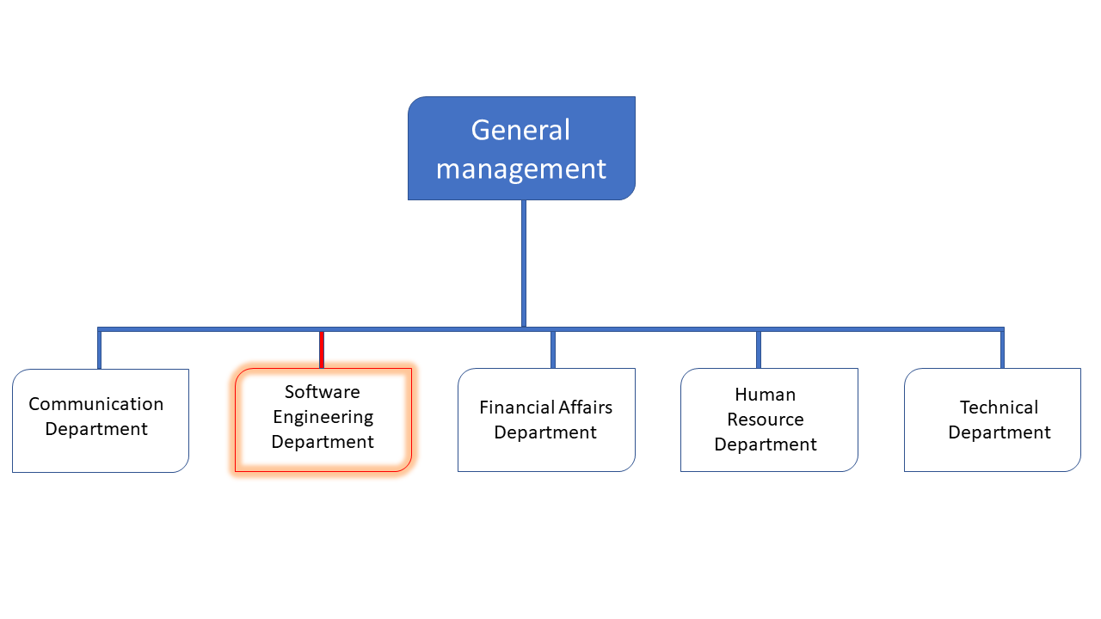
Figure 1: Functional Organization of Realize

GEOGRAPHICAL LOCATION
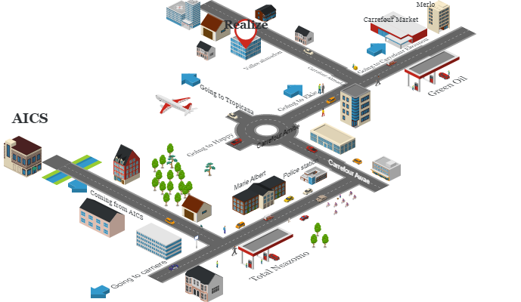
Figure 2: GEOGRAPHICAL LOCATION OF REALIZE

BRIEF PRESENTATION OF THE PROJECT THEME
Following our arrival at REALIZE, we were encouraged to suggest innovative project ideas for our internship. Following the mission of REALIZE that demonstrate the company’s willingness to take active part in the sustainable development of the world through innovative solutions, we saw the room for creativity in our project idea and proposed the theme “DEVELOPMENT OF A PATIENTS’ CONSULTATION AND FOLLOW-UP PLATFORM FOR CAMEROON GOVERNMENT HOSPITALS”. This system that we named iKare is made up of an admin dashboard, a super admin dashboard that is the Minister of Public Health, Patient’s dashboard, Doctor’s dashboard for trained medical professionals.
iKare’s patient’s dashboard provide the patients with a list of available hospitals from which he/she can get a list of trained medical personnels in various fields where they can book for an appointment for consultation or in cases of emergency locate the closest hospital or free health professional, a chat section for discussions with these medical professionals on light or less serious cases, a geolocalisation section where they can locate the different pharmacies that are opened at that particular time, that have the required drugs they are looking for and most importantly that are not far from their current position. Consultations are also made through video calls.

CONCLUSION
Our insertion phase at REALIZE lasted for two (2) weeks. We discovered the amazing environment where we found ourselves in. This environment gives room for hard work, perseverance and collaboration, what most students are looking for. We learned about the missions of the company, its activities. We met and got acquainted with the staff and other interns at REALIZE. Finally, we chose our theme “DEVELOPMENT OF A PATIENTS’ CONSULTATION AND FOLLOW-UP PLATFORM FOR CAMEROON GOVERNMENT HOSPITALS”.

PART II

EXISTING SYSTEM

Preamble
The existing system is a document that provides a view of the system currently in place, that is how it carries out its different activities, also it provides a deep understanding of this system associated to the various limitations, the problems that result from these and the solution we propose.
INTRODUCTION
- PRESENTATION OF THE THEME
- STUDY OF THE EXISTING SYSTEM
- CRITICISMS OF THE EXISTING SYSTEM
- PROBLEMATICS
- PROPOSED SOLUTION
CONCLUSION

Content

INTRODUCTION
As Engineers our role in the society is problem-solving which is targeted at making life easier for everyone and in order to bring forth a solution, we ought to ask ourselves some questions to know why the problem exist in the first place and how it is being dealt with at the time. The existing system refers to the system put in place to carry out the work done in the field on which our theme is based. Understanding this system is a great step in solving the problems that we might identify. It’s of great importance that we take into consideration this system before proposing a suitable solution that will ameliorate or replace the current one.

PRESENTATION OF THE PROJECT THEME
Our theme is “DEVELOPMENT OF A PATIENTS’ CONSULTATION AND FOLLOW-UP PLATFORM FOR CAMEROON GOVERNMENT HOSPITALS”. This application (iKare) will enable a distance consultation of patients by doctors. If we take the case of Corona Virus in 2020, we recall that it is an air borne disease, so easily transmitted in crowded areas. In our case a hospital is not only crowded but also a container of so many diseases especially during a pandemic. The idea is not to eliminate visits to a doctor by a patient which in my opinion is impossible, we want to limit such visits to limit the spread of diseases, transport costs and all other issues. Consultation will be done through video calls, chat messages for less serious cases, patients can also book for appointments with doctors for consultation either online or physically. At the end, depending on the doctor’s diagnosis the patient will receive a prescription of drugs he/she needs to buy. The application is also equipped with a pharmacy search section, where a list of pharmacies closer to the patient is displayed, the patient filters the list by drug name, opened pharmacies.
In case lab tests are required, the patient can book an appointment for lab tests at his desired time. Also, while taking the drugs, the patient is been follwed-up by a series of forms he fills concerning, the progress of his medication and how is feeling. If the current health situation is not good after 2/3 of the medications taken, the doctor is alerted.
iKare does not only allow consultations, scheduling doctors program, searching pharmacies, booking appointments for lab tests but also patients follow-up. All these to the patients’ advantage.

DESCRIPTION OF THE EXISTING SYSTEM
We notice more and more an overheating of health centers because of the
exponential increase of patients in Africa in general and in Cameroon in particular.
As a result, health professionals are faced with a busy and often poorly organized
schedule. Also, patients are constantly encountering problems during their medical
follow-up. This is because they have to wait in long lines to be seen or even not be
able to see a doctor. Even if an appointment has been made, it is possible that it is
cancelled and the patient is not aware of it.
From a survey carried out from the 28^{th of} July to 01st August 2023, the following results were obtained:
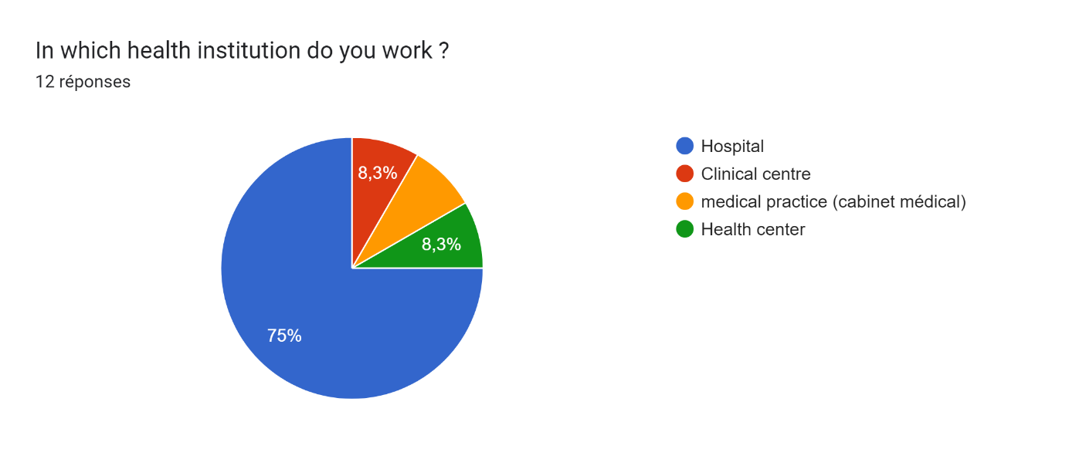
Figure 3: Doctor Survey Question 1
- 75% of the doctors work in a hospital while the 25% of the ones left are redistributed equally in a clinical center, health center and medical practice.

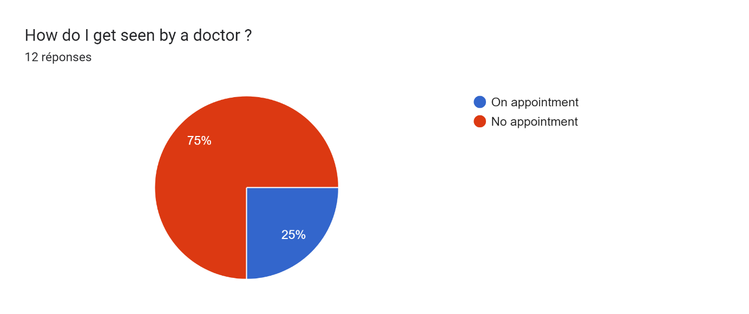
Figure 4: Doctor Survey Question 2
- 75% of doctors don’t attend by appointments.

Figure 5: Doctor Survey Question 3
66.4% of the doctors work in Yaounde.
From the above results, we came out with the following observations
- Most health institutions consult without making appointments. A patient arriving at the institution usually encounters long queues. The patient usually waits for quite a long time before his parameters like body temperature, blood pressure, weight are collected by nurses after he/she is done with the consultation fee.

- During the various exchanges between the patient and the doctor, certain questions are asked by the specialist in order to be able to identify the history and the illness from which the patient is suffering.
- At the end of the consultation, the doctor diagnoses and based on this diagnosis issues prescription to the patient.
- The patient buys the drugs at the health institute’s pharmacy or if not available moves around looking for another where he can purchase the drug.
- If there are any tests to be carried out, the patient pays for the tests and goes to the laboratory where he gives a sample of his blood, faeces, urine or any other organic matter to the lab technician for analysis. The duration of the tests and results vary according to the specific tests involved. It usually varies from hours to days or weeks.
- Some follow ups are done at the level of the health institution (inpatient follow-ups) while others are done through calls (outpatient follow-ups) or doctors can schedule an appointment with the patient to try to see the evolution of the prescribed treatment, possibly present the results of a prescribed examination in order to find the anomaly.
- In case of emergency the patients are first taken care of before any identification according to the severity of the disease.

LIMITATIONS OF THE EXISTING SYSTEM
At the end of our collection of information concerning the medical consultation process in hospitals, we find that this system has weaknesses that should not be overlooked despite their warm welcome. However, it should be noted that some observations have been made within the clinic and it would be wise for us to suggest solutions to the various problems noted.

Table 1: Limitations, Consequence and proposed solution
LIMITATIONS | CONSEQUENCE | PROPOSE SOLUTION
A queue of sick people such as dizziness or a headache, the patient is forced to line up and wait for long hours to get a doctor's advice | - The care of patients is not easy  - Purchase and consumption of drugs offered by street vendors. | - System proposes available doctors for remote consultation.  - Set up spaces for "Online doctors".
Huge transport costs for people living in remote areas without a nearby hospital. | Calls to neighborhood doctors | Reduce these expenses by setting up an online medical consultation, no matter where the patient is.
Little or no communication between the doctor and the patient, the latter who will be forced to travel whenever the disease progresses. | Self-medication resulting in death of the patient in most cases. | Facilitate the dialogue between the doctor and his patient by setting up a video call module.
Drugs not always found in the nearby health institute’s pharmacy or nearby hospitals (pharmacies). | Unnecessary moving around town in search of the drugs which can delay time of taking the drugs and can cause death in severe cases. | Developing a platform that facilitates search of pharmacies depending on location, drugs available, day shifts.
Appointments and schedules still done manually | Patient is not well taken care of and might lead to confusions and forgetfulness. | Developing a platform that manages appointments and schedules to avoid these confusions
Transport costs spent on outpatient follow-ups | Patient does not arrive on time and is not well taken care of. | Enhance follow-up through daily surveys on the platform and alerting a doctor in case of unexpected change or behavior.

PROBLEMATIC
Since dialogue is the basis of a medical consultation, it is more than necessary that it be done in a simpler and more explicit way as possible because human lives are at stake. Through these various observations, we ask ourselves the question HOW CAN WE FACILITATE ONLINE COMMUNICATION BETWEEN PATIENTS AND DOCTORS, FOLLOW-UPS OF PATIENTS AND ACCESS TO PRESCRIBED DRUGS FROM PHARMACIES? We will try to offer a solution through our application.

PROPOSED SOLUTION
After our study and criticism of the existing situation, we propose to design a Web and a mobile application that will allow the citizen (Health professionals and Patients) of Cameroon to:
Health Professionals
- Have Electronic Agenda to manage availability and Appointment.
- Chat with patients.
- Consult through video calls.
- Set patients prescription online.
Patients
- Localize all nearby health institutes.
- View Health Specialist availability from different health institutes.
- Chat will health professionals.
- Receive notification after appointment reschedule.
- View medical prescription.
- Localize nearby, opened pharmacies.

CONCLUSION
Having reached the end of this part, we studied the existing system by questioning different health professionals in different institutes through the survey that enabled us to come out with the limitations of the system that leads to the consequences and we proposed solutions to the various limitations. Finally we proposed our solution which is a mobile and web application.
This step is necessary because we need to understand how the system put in place currently works before we can facilitate or ameliorate the processes been carried out in this system.

PART III

SPECIFICATION BOOK

Preamble
The Specification book is a document which is been established by the customer needing a particular product and the producer (engineer) who is to create the product, which is to be respected to its fullness during the realization of the product. From this, we obtain the major importance of the specification book.

Content

INTRODUCTION
- CONTEXT AND JUSTIFICATION
- OBJECTIVES OF THE PROJECT
- EXPRESSION OF NEEDS
- ESTIMATED COST OF THE PROJECT
- PROJECT PLANNING
- LIST OF PARTICIPAANTS AND DELIVERABLES.
CONCLUSION

INTRODUCTION
The specification book of our report helps us provide details about our theme to improve our understanding of it and increase the likelihood of it succeeding. To delimitate the scope of our project, we will specify the context of our theme. From the context, we will list the problems we have decided to address throughout the project. After presenting our solution, we will talk about the objective we have set for the project. Also, we will explore the needs to which our system will respond both at the functional and non-functional level. We will then look at the estimated financial requirements for our project and establish a plan we will follow to complete our project on time. From here, we will discuss what is expected of us by the end of the project under the project deliverables.

CONTEXT AND JUSTIFICATION

Context
Cameroon is a home to closely 28,703,875 million inhabitants and in situations where a pandemic is declared, the feeling of anxiety and uncertainty can overwhelm people, and health system can struggle to cope with an uncontrolled and exponential demand. There are approximately 1.1 physicians and 7.8 nurses and midwives per 10,000 populations (WHO AHWO Cameroon Fact Sheet, 2010).
A survey carried out from July 29th to July 31st, 2023, revealed the following results.
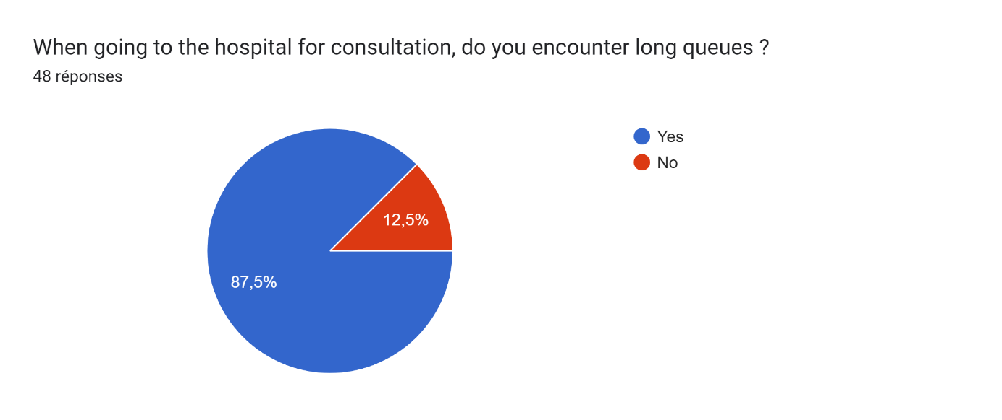
Figure 6: Patient Survey question 1
We can see from the above that, of the 48 people who answered to the questions from the survey, 87,5% encounter queues when going to the hospital. Also,
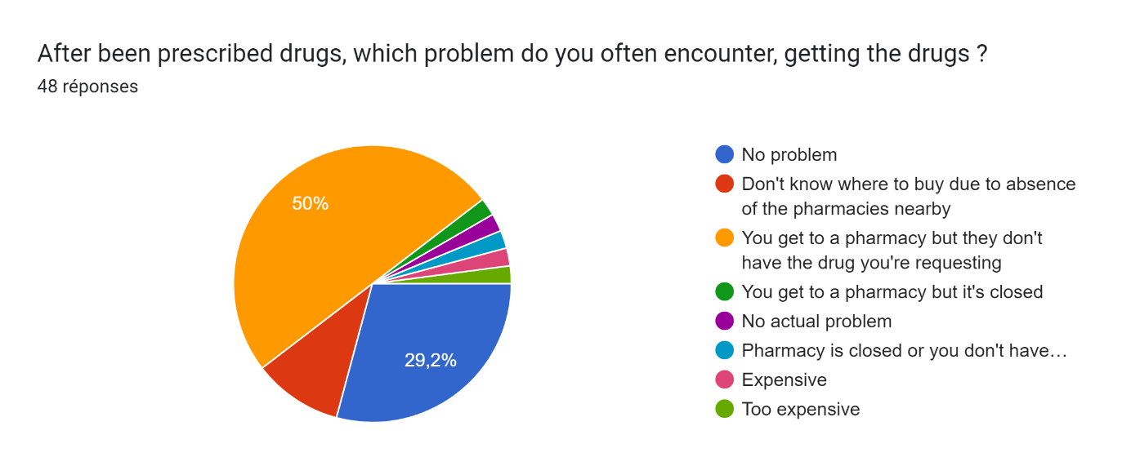
Figure 7: Patient Survey Question 2
It’s clear that only, 29.2% of those interviewed don’t have a problem getting a prescribed drug, the rest are distributed between locating the pharmacy that’s opened at that moment, locating the pharmacies nearby, getting the drug from the opened pharmacy, or knowing ahead of time the price of the drug you are looking for ensuring you have enough money on you.

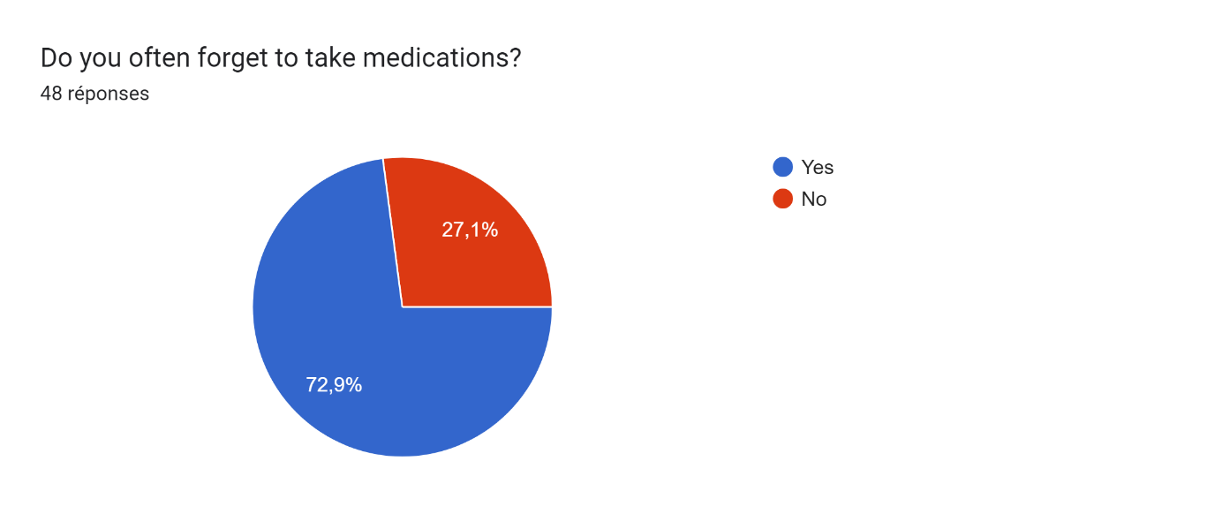
Figure 8: Patient Survey Question 3
We can also see that 72.9% of those who answered often forget to take medications, they might have many things in mind and can’t even see the time pass.
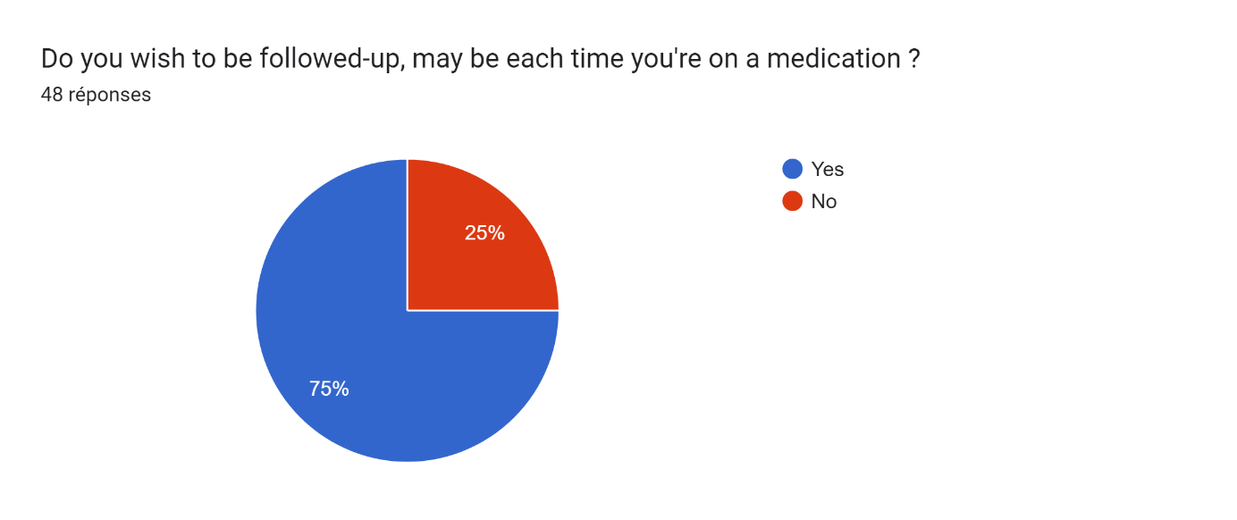
Figure 9: Patient Survey Question 4
We can also notice that 75% of those who answered require follow-up each time they are prescribed a drug or each time they are on medication.

Justification
The health sector is experiencing a growing number of patients. As a result, with hospitals and clinics overheated, the management of patients and their medical follow-up is a major problem for patients and doctors. Insofar as it is for the most part impossible to know the availability of health professionals and to make an appointment or to be consulted on time. Even after consultation, patients do not know how to continue especially when the hospital’s pharmacy does not have the required drugs, they are looking for. They might be moving around the whole town looking for a specific drug because either the pharmacies they find don’t have that specific drug, they are closed, or the price of the drug is beyond their expectations.
For this reason, iKare will allow the patient(s) to be consulted remotely, without having to follow a queue, or by taking appointments depending on your availability. The notion of distance here means that the doctor and the patient are not in the same place during the consultation; and this will limit the risk of contamination, save time, and have centralized management of patient data. Also, iKare will favor searching of pharmacies by filter, that is according to those nearby, opened, having the required drugs and raising awareness concerning the price of the medication. Patients will be able to book appointments for lab tests.

OBJECTIVES OF THE PROJECT

GENERAL OBJECTIVE
The main objective of this project is to facilitate remote consultation, follow-ups of patients and facilitate the search of pharmacies.

SPECIFIC OBJECTIVES
- The patients will be able to log into the platform, book for an appointment for video consultations.
- Be consulted, diagnosed and issued prescriptions according to the diagnosis carried out by the doctor.
- Book for tests in a laboratory if required, the tests are sent directly to the laboratory from the doctor.
- Receive a list of all pharmacies and applying a filter by location, drug searched and pharmacy type (day / night).
- To be followed up, during the illness to recovery period, through regular surveys on how they feel.
- Discuss with doctors through chat messages for less serious cases.

EXPRESSION OF NEEDS

Functional Needs
In this context, functional requirements describe what the system or application should do. The modules are as follows;
- The administrator (admin) should be able to:
- Account Creation: The health Institute Admin is responsible for creating the health professionals’ accounts and lab administrators’ accounts for a particular health institute.
- Account Management: Here users can manage their account by modifying some of their information.
- User Authentication: Allow the users to register or login into the application while also providing a secure mechanism to recover their account in case they forgot their password or otherwise. In addition, the user account must be confirmed to ensure identity proof.
- Manage Electronic Record Book: Here the patients can upload recent medical booklets, these records are kept secured on the platform, each time medical personnel wishes to access it, he/she requires permission from the patient. Also, the patient’s data are encrypted using sophisticated algorithms.
- Localize pharmacies: Here patients will get a view of all pharmacies nearby, opened by that time and which have the required drugs they are looking for.
- Manage Appointment: Here doctors have an agenda where they can validate, cancel, re-schedule an appointment, view their appointment date and even set a reminder.
- Follow-up: Allow the users to answer a series of questions each time they take a specific drug, this allows the production of a dataset and notifies the doctor in charge when the patient situation is abnormal.
- Exchange between Patient and Health Professional: It provides an interface where the doctor can have online consultation with patients who make an appointment. Allows health specialists to create meeting an add more participants, also a translation module will enable native speakers communicate with medical professionals, removing language barriers.

Non-Functional Needs
They specify the quality attribute of a software system. They judge the software system of application based on Performance, Responsiveness, Usability, Security, Portability and other non-functional standards that are critical to its success. Failing to meet non-functional requirements can result in a system that fails to satisfy user need.

Performance, Scalability and Security
Performance defines how fast a software system, or its piece responds to certain user’s action under certain workload. In most cases, this metric explains how much a user must wait before the target operation happens (the page renders, a transaction is processed, etc.) given the overall number of users at the moment. But it’s not always like that. Performance requirement may describe background processes invisible to users. Our goal will be to provide our users with the best performance as it affects the overall user experience.
Scalability accesses the highest workloads under which the system will still meet the performance requirements. In this project we will mainly leverage the power of cloud storage and third-party API’s.
- The application should have a friendly user interface (UI) and should be easy to use.
- The code should be clear to facilitate future development and improvement.
- The web application should be resizable when opened on any device (android phone, computer, tablet web browsers
Security is also one of the most important aspects of any system, especially the ones dealing with sensitive user’s information.
- The application should provide a strong security mechanism to reassure user’s that they can trust it for their sensitive information.
- Some of the security principles include reassuring confidentiality, accountability, Integrity, Authentication.

PROJECT PLANNING

Chronogram of activities
Table 2: Chronogram of activities
PHASE | OBJECTIVE | OUTPUT | DURATION | PERIOD
INSERTION | Collection of information on the enterprise | Insertion book | 2 weeks | 03rd July to 14th July
EXISTING SYSTEM | Study of the existing system | Existing System | 1 week | 17th July to 21st July
SPECIFICATION BOOK | Specification of the user needs | Specification Book | 5 days | 24th July to 28th July
ANALYSIS | Capture of needs Use case and textual description Modelling | Analysis Book | 2 weeks | 31st July to 11th August
CONCEPTION | Preliminary conception and Detailed conception | Conception book | 2 weeks | 14th August to 25th August
REALIZATION | Implementation Unitary test Integration Test Development, Deployment, Component diagrams | Realization book | 3 weeks | 28th August to 15th September
TEST OF FUNCTIONALITIES | Testing of the software and debugging | Test of functionalities | 1 week | 18th September to 22nd September
INSTALLATION AND USER GUIDE | Documenting software | User Guide | 1 week | 25th September to 29th September

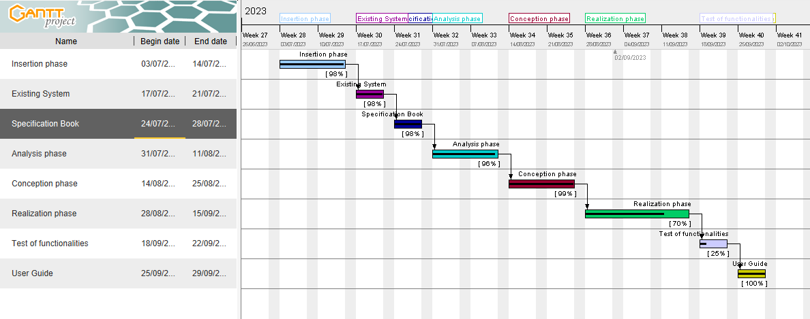
Gantt Project planning
Figure 10: Gantt project planning

ESTIMATED COST OF THE PROJECT

Software Resources
Table 3: Software Resources (source : Mercurial 2022)
RESOURCES |  | DESIGNATION | USAGE | QUANTITY | UNIT COST (FCFA)
Formatting | Microsoft Office 365 |  | Writing of the report | 1 | 47 998
Cloud Storage | Google Cloud |  | Saving our report | 1 | Freemium
Web browser | Google Chrome |  | View web pages | 1 | Freeware
Code Editor | Visual Studio Code |  | For writing the code of the application | 1 | Freeware
Project planning | Gantt Project |  | For building a Gantt chart | 1 | Freemium
Illustrating tool | Ichogram |  | For building a geographical location of the enterprise | 1 | Freemium
UML Analysis | Sybase  PowerAMC |  | For drawing UML diagrams | 1 | Freemium
Testing Mobile App | Expo Go |  | For testing the mobile application | 1 | Freemium
TOTAL 1 |  |  |  | 8 | 47 998

Hardware Resources
Table 4: Hardware resources (source: https://www.scribd.com/document/561202966/mercuriale-2022)
RESOURCES | HARDWARE | Quantity | UNIT COST (FCFA)
Computer | LAPTOP HP ELITEBOOK 8540P CORE I5, DISQUE DUR 500 GO, RAM 4 GO, ECRAN LARGE 15" HD | 1 | 402 500
Printer | Printers | 1 | 546 250
Network | Local network installation | 1 | 300 000
Removable Disk | Removable Disk | 1 | 11 555
Smart phone | Smart phone | 2 | 150 000
TOTAL 2 |  | 6 | 1 410 305

Human resources
Table 5: Human Resources (source : Mercurial 2022)
ROLE | NUMBER OF DAYS | QUANTITY | COST PER DAY | TOTAL PRICE (FCFA)
Project Manager | 90 | 01 | 30 000 | 2 700 000
Analyst | 21 | 01 | 25 000 | 525 000
UI/UX Designer | 07 | 01 | 20 000 | 140 000
Programmer | 30 | 01 | 15 000 | 450 000
Tester | 14 | 02 | 10 000 | 140 000
Margin error | / | / | / | 1,475,000
TOTAL 3 |  |  |  | 4 840 000

Global Estimation
Table 6: Global Estimation
TOTAL 1(FCFA) | TOTAL 2(FCFA) | TOTAL 3(FCFA) | OVERALL TOTAL (FCFA)
47 998 | 1 410 305 | 4 840 000 | 6 298 303
SIX MILLION TWO HUNDRED AND NINETY-EIGHT THOUSAND THREE HUNDRED AND THREE

CONSTRAINTS
- Technical constraint
For the development of our system, we have sufficiently robust tools to guarantee a minimum of security, extensibility and excellent scalability. Moreover, the programming phase will have to follow all the technical standards for a better performance in a reduced execution time, this is why the choice of the development technologies is crucial.
- Time Constraint
The project will be realized in 13 weeks (3 months) starting from the beginning date, July 3rd, 2023.
- Cost constraint
The realization of our project will require expenditures in human resources, material and software a total cost of 6 298 303 FCFA.

LIST OF PARTICIPANTS AND DELIVERABLES

LIST OF PARTICIPANTS
Table 7: List of participants
NAME | FUNCTION | ROLE
Mr. TANUE Monette | Follows up interns at the company level | Professional supervisor
Mr. AGBOR Anderson | Follows up student at the academic level | Academic Supervisor
KAMENI SEPDEU Ange Chris | AICS Student Intern | Student at AICS

DELIVERABLES
- In project management, any component materializing the result of a realization service is called a deliverable. In the case of our project, the deliverables are: A report composed of the following document
- The application.
- The user guide.
- The powerpoint.

CONCLUSION
Reaching the end of this part. The list of objectives to be achieved has been enumerated and made clear. The specification book permitted us to present the different actors associated with the project as well as the requirement and the provisional planning needed for the achievement of our project. We will move directly to the next part which is the analysis phase. In the analysis phase, we will model our system with a modelling language and a unified process, do a comparative study of uml and merise.

PART IV

ANALYSIS BOOK

Preamble
The main objective of the analysis phase is to capture the user’s need, the delimitation of the field of study and to have a clear understanding of the system in study. To achieve this, we will use UML (Unified Modelling Language) with the 2TUP (2 Track Unified Process) as method applied to UML to analyze the system. We will start by doing a comparison between UML and MERISE, of various unified processes and lastly, we will present the modelling of the solution we propose (Our software).

Content
INTRODUCTION
- METHODOLOGY
- COMPARATIVE STUDY OF UML AND MERISE.
- COMPARATIVE STUDY OF UNIFIED PROCESSES.
- CHOICE OF THE ANALYSIS METHOD
- MODELLING OF THE PROPOSED SOLUTION
CONCLUSION

INTRODUCTION
System development can be thought of as having two major components: System analysis and system design which both help in understanding the details of the existing system or the system to be designed. The analysis and design of information systems has most of the time vocation to allow the creation of databases, which must represent as closely as possible the reality of the field studied thus requiring the use of a design method. This is why our choice will be directed on the UML method as it offers much to developers seeking a user-centered approach and / or a wide scope in design. This part of the report consists of the comparative study of UML and MERISE, unified processes and finally the various diagrams that meet the functional need requirements.

METHODOLOGY

COMPARATIVE STUDY OF UML AND MERISE

MERISE
MERISE stands for “Méthode d’Etude et de Réalisation Informatique pour des Systèmes d’Entreprise”. Although it is prescriptive to some extent, MERISE permits the participation of end users and senior management as well as data processing professionals in its decision cycle. MERISE is a method for designing, developing and carrying out IT projects. The goal of this method is to achieve the design of an information system. The MERISE method is based on the separation of data and processing to be carried out in several conceptual and physical models. The essentials of the approach lie in its three cycles: the decision cycle, the life cycle and the abstraction cycle, which cover data and process elements equally. The separation of data and processing ensures longevity in model. Indeed, the arrangement of data does not have to be often overhauled, while treatments are more frequently.

UML
UML (Unified Modelling Language) is a standard notation for the modelling of real world objects as a first step in developing an object-oriented design methodology. Its notation is derived from and unifies the notations of three object-oriented design and analysis methodologies: Grady Booch's methodology for describing a set of objects and their relationships, James Rumbaugh's Object-Modelling Technique (OMT), Ivar Jacobson's approach which includes a use case methodology. Other ideas also contributed to UML, which was the result of a work effort by Booch, Rumbaugh, Jacobson, and others to combine their ideas, working under the sponsorship of Rational Software. UML captures information about the static and dynamic view of a system. UML 2.5 comprises of 14 diagrams which represent the different views of a system. The 14 diagrams can be subdivided into two, Static or structural and Dynamic diagrams. These diagrams include;
- STATIC OR STRUCTURAL DIAGRAMS
- Class diagram;
- Object diagram;
- Component diagram;
- Deployment diagram;

- Composite Structure diagram;
- Package diagram;
- Profile Diagram;
ii. BEHAVIOURAL OR DYNAMIC DIAGRAMS
- Use case diagrams;
- Activity diagram;
- State machine diagram;
- Sequence diagram;
- Communication diagram;
- Global Interaction diagram;
- Timing Diagram;
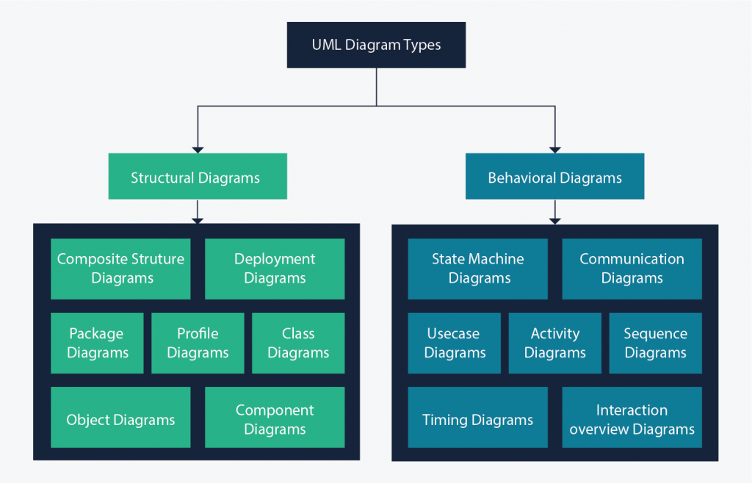
Figure 11: UML 2.5 diagrams overview (source: https://creately.com/blog/diagrams/uml-diagram-types-examples/)

On very important notice is that UML is not a method but a modelling language. As such to give it an approach we need to associate UML to a Unified Process (UP) in other to give our conception a methodology to follow. There exist several Unified Processes, but our modelling approach will be the 2TUP (Two-track unified process) which we will use in the course of our project.

Table 8: Differences between UML and MERISE
MERISE | UML
It stands for Méthode d'Étude et de Réalisation Informatique pour les Systèmes d'Entreprises | Unified Modeling Language
MERISE is a systemic method of analysis and design of information systems. That is, it uses a systems approach. | UML is however not a method but rather an object modeling language to which it is necessary to associate an approach to make it a method. This is the case with the 2TUP method; RUP and XP.
MERISE proposes to consider the real system from two points of view: - A static view (data) - A dynamic view (treatments). That is, with the MERISE method, we have a separate study of the data and the treatments. | UML offers a different approach from that of MERISE in that it combines data and processing. Because with UML, centralizing the data of a type and the associated processing makes it possible to limit the maintenance points in the code and facilitates access to information in the event of software development. In addition, UML describes the dynamics of the information system as a set of operations attached to the objects of the system.
Rational | Object

COMPARATIVE STUDY OF UNIFIED PROCESSES

A Unified Process
A Unified Process is a process of development of software constructed on UML; it is iterative, incremental, centered on architecture, driven by use cases and requirements.
Iteration is distinct sequence of activities with a basic plan and evaluation criterion that produces an internal or external output. Either the content of an iteration is improved, or the evolution of the system is evaluated by users.
An increment is the difference between two released products at the end of two iterations. Each iteration that the group is capable of integrating the technical environment in order to develop a final product and give users the possibility of having tangible results.
Centered on architecture the different models derived during the establishment of system must be reliable and coherent.
Driven by use case and requirements enables the clear definition of a users’ needs and priorities respectively thereby minimizing the risk of project failure.

The Two Track Unified Process (2 TUP)
2TUP is a unified process which is built on UML and has as objective to bring solution to constraints of functional and technical changes imposed on information systems by strengthening controls on development capacities. It proposes a Y-sharped development life cycle that separates the functional aspect from the technical aspects, and the merging of these two forms the implementation aspect. 2TUP distinguishes therefore two branches: the functional and technical branches, the combination of the result of these two branches forms the third: the realization branch – where we realize our system. The diagram below illustrates the branches of 2TUP.

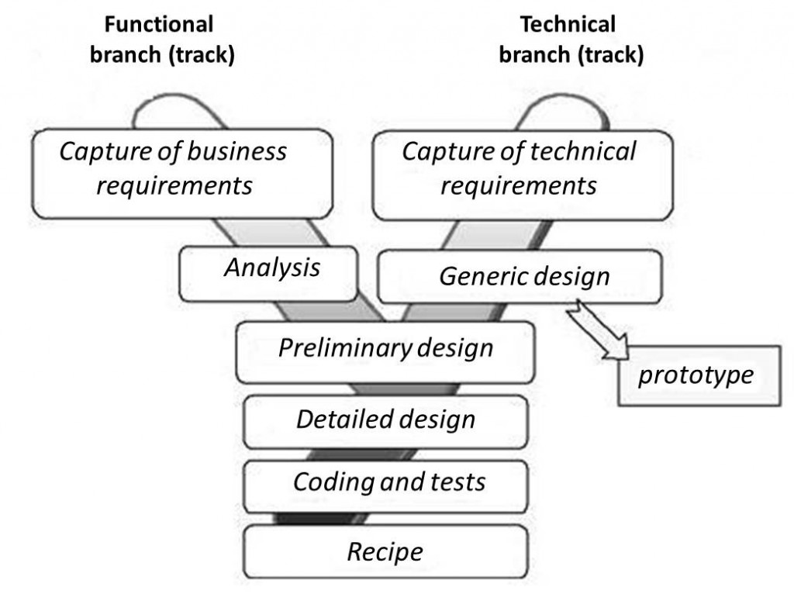
Figure 12: 2TUP diagram (source: https://www.mysciencework.com/omniscience/pervasive-mobile-healthcare-system-based on-cloud-computing).

- The left branch (functional branch)
It captures the functional needs of a system. This ensures the production of software that meets the needs/requirements of the user. The analysis here consists of studying precisely the functional specification in order to obtain an idea of what the system is going to realize, and its result does not depend on any technology.
- The right branch (Technical branch)
The technical branch enumerates the technical needs and proposes a generic design validated by a prototype. The technical needs include constraints and choices related to the conception of the system, the tools and equipment as well as the integration constraint with the existing system condition.
- The middle branch (Realization or Implementation branch)
In this branch, we study the preliminary conception, detailed conception, and documentation of the system. The realization branch supports the following: Preliminary conception: This is the most sensitive step of 2TUP as it is the confluence of the functional and technical branch. It is completed when the deployment model, the operating model, the logical model, interphases and the software configuration model are defined. We have the following diagrams:
- Component Diagram ;
- Deployment Diagram ;
- Package Diagram ;
- Composite Structure Diagram ;
Detailed conception: This is the detailed design of each feature of the system. We have the following diagrams:
- Class;
- Object;
- Sequence;
- Timing Diagram;
Coding and testing: This is the phase where we program the designed features and test the coded features.
The recipe: Also known as the deliverables is the validation phase of the functions of the developed system.

CHOICE OF THE ANALYSIS METHOD
The reason why we chose UML modelling language and the software development process 2TUP instead of many others that exist, include:
UML is the current standard for programming in an object-oriented language. For this reason, it is widely understood and well known making it easy for a new programmer to join the project and be productive from the very first day.
UML diagrams allow teams to virtualize how a project is or will be working, and they can be used in any field, not just software engineering. The diagrams will allow teams to virtualize together how a system, or a process will work or did work. It can provide new ideas for how teams have to collaborate to achieve the goal of the workflow process.
2TUP is centered around the creation and maintenance of a model, rather than the production of mountain documents.
2TUP is user oriented as it permits the development of software that responds to the needs of the users through the study of the user needs.
2TUP is iterative and incremental, hence it enables the project team to produce refined amelioration if necessary and easily integrate it in the already existing system.
2TUP by permitting the project team identify and test the key functionalities of the system limits the risk related to building the system.

MODELLING OF THE PROPOSED SOLUTION

Capture of Functional Needs
The first step of the left (functional) branch of Two Track Unified Process (2TUP) is the capture of the functional needs. At this step, we capture the intended behavior of the system that maybe express as services, tasks or functions the system is required to perform.

USE CASE DIAGRAM
- Definition
Use case diagram shows the functionalities of a system, their interdependencies and how they relate with actors of the system. A use case is a specification of behaviour. The main objectives of the use case diagram are:
- Provide a high-level view of the system.
- Identify the functions of the system.
Use case diagrams are completed with a textual description of each use case that is intended to define the use case in greater details.
- Formalism
Figure 13: Use Case Diagram formalism

Table 9: Use Case Diagram Component
Elements | Notation | Description
Actors |  | Represents an entity that directly interacts with the system. The actor is what performs the different possible actions of the system
Use case |  | A use case represents a functionality of the system. It is an action that can be performed by an actor.
Association |  | it indicates that an actor takes part in a use Case.
Include |  | An inclusion denotes that an included action must be performed before the including action can be performed.
Extend |  | An extension denotes that an extending action may be performed while an extended action is being performed.
Generalization |  | This shows that an actor or a use case is a kind of another abstract or concrete actors can be defined and later specialized using generalization relationship.
System |  | It is a container of use cases which interact with external actors

- The Actors of our System
Table 10: Actors of our System
Actor | Role
Administrator | The administrator is responsible of managing the accounts of patients and health professionals (validating, deleting accounts) and general functioning of the system.
Super Administrator | He also manages the whole system and all the users (including the administrator)
Patient | The user that receives services from the health professionals and the apps
Health Professional (Doctor) | These are verified personnel in charge of counselling and providing consultation to the users.
Geolocation API | Aids in the geographical location of the searched and selected pharmacy
Payment API | Provides payment services to the application in terms of MTN mobile money and Orange Money.
SMS API | Provides a service to send SMS to users, notifying them of updates on your account.

- General Use Case Diagram

Figure 14: General Use Case Diagram

- Consult appointment use case diagram

Figure 15 manage appointment use case diagram
- Consultation use case diagram

Figure 16: consultation use case diagram

- Textual description of use cases
Table 11: Authenticate Textual Description
Title | Authenticate
Summary | The user needs to authenticate
Actors | Patient, Health Professional, Lab technician
Date | September 11, 2023
Stakeholder | iKare Directors
Version | 1.0
Precondition (s) | - The app is launched.  - The actor has an account on the platform.
Triggers | The user clicks on login button
Nominal Scenario | - The system displays the login form.  - The actor fills and submits the form.  - The system verifies conformity of the form fields  - The system sends the data to the dbms.  - The dbms returns result of the query.  - The system displays a success message to the actor.
Alternative Scenarios | - At step 4 of the nominal scenario, the user enters mismatched or missing information.  - The system displays an error message then returns to step 2 of the nominal scenario.
Postcondition of success | The user has access to his/her dashboard
Postcondition of failure | The user does not have access to the platform
Non-functional requirement | Entering the password must not be visible on the screen

Table 12: Book appointment textual description
Title | Book appointment
Summary | The user books for a consultation appointment.
Actors | Patient
Date | September 11, 2023
Stakeholder | iKare Directors
Version | 1.0
Precondition (s) | The actor is authenticated.
Triggers | The user clicks on book appointment button.
Nominal Scenario | - The actor has authenticated.  - The system displays the list of hospitals.  - The actor selects a hospital from list.  - The system displays the doctors from the hospital.  - The actor selects a doctor.  - The system displays a form.  - The actor fills and submits the form.  - The system displays a success message
Alternative Scenarios | - At step 4 of the nominal scenario, the user enters mismatched or missing information.  - The system displays an error message then returns to step 2 of the nominal scenario.
Postcondition of success | The user has booked for an appointment.
Postcondition of failure | The user has not booked for an appointment.

Table 13: Video Consultation textual description
Title | Video Consultation
Summary | The user needs to consult through video calls.
Actors | Health Professional
Date | September 11, 2023
Stakeholder | iKare Directors
Version | 1.0
Precondition (s) | The actor has authenticated
Triggers | The user clicks on consult button
Nominal Scenario | - The actor authenticates.  - The system displays a list of upcoming appointments.  - The actor clicks on appointment card.  - The system displays the appointment details.  - The actor clicks on launch call button.  - The system displays video consultation UI.
Alternative Scenarios | - At step 5 lack of network connectivity arises  - The system displays an error message
Postcondition of success | The actor is able to consult.
Postcondition of failure | The actor can’t consult.
Non-functional requirement | There must be a good network connectivity.

COMMUNICATION DIAGRAM
- Definition
Communication Diagrams model the interactions between objects in a sequence. They describe both the static structure and the dynamic behavior of a system. It is a simplified version of a Collaboration Diagram introduced in UML 2.0. A communication diagram is more focused on showing the collaboration of objects rather than the time sequence.
- Formalism

Figure 17: Communication Diagram formalism
- Components of a Communication Diagram
Table 14: Elements of a communication diagram
ELEMENT | NOTATION | DESCRIPTION
Message |  | Designs a particular communication between lifelines.
Connectors |  | It represents the relationships that exist between lifelines
Dependency |  | A dependency is a relationship that signifies a single or a set of model elements for their specification
Lifeline |  | An object represents an individual participant in the interaction conversation.

- Authenticate Communication Diagram
Figure 18:Auhenticate Communication Diagram

- Book appointment communication diagram
Figure 19 Book appointment communication diagram

SEQUENCE DIAGRAM
- Definition
A Sequence diagram describes interactions among classes in terms of an exchange of messages over time. They are also called event diagrams. A Sequence diagram is a good way to visualize and validate various runtime scenarios. These can help to predict how a system will behave and to discover responsibilities a class may need to have in the process of modelling a new system.
- Formalism
Figure 20: Formalism of sequence diagram

- Components of Sequence Diagram
Table 15: Elements of sequence diagram
ELEMENT | NOTATION | DESCRIPTION
Lifelines |  | They represent rows or objects instances that participate in the sequence being modelled.
Asynchronous Message |  | It is a message that receives an indirect response.
Synchronous Message |  | It is a message that sends and want response before it continues a process
Self-Message |  | self-message can represent a recursive call of an operation, or one method calling another method belonging to the same object.
Return Message |  | It represents the response of a message.
Actor |  | They send and receive message.
Combined Interaction Fragment |  | An articulation of interaction diagram, defined by an operator and operands.

- Authenticate sequence diagram
Figure 21: Authenticate Sequence Diagram

- Book appointment sequence diagram
Figure 22 Book appointment sequence diagram

ACTIVITY DIAGRAM
- Definition
An activity diagram is a graphical representation of workflows that show the steps needed in the realization of a process; showing the details from a start point to an end point through all decisions and actions that can possible be performed. Activity diagrams are intended to model both the computational and organizational process. They flow can be sequential, branched or concurrent. Below is an activity diagram formalism.
- Formalism
Figure 23: Formalism of activity diagram

- Elements of activity diagram
Table 16: Elements of activity diagram
Element | Diagrammatic Representation | Description
Activity | 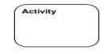 | Used to represent a set of actions.
Action |  | Represent a task to be performed.
Activity edge |  | A directed connection between two activity nodes through which tokens may flow
Initial node |  | Shows the beginning of an activity or set of actions.
Final node |  | Stops all controls and object flows in an activity.
Object node |  | Represents an object connected to a series of object flows.
Decision node |  | Represents a test condition that slits an incoming activity edge into opposite outgoing activity edges.
Merge node | 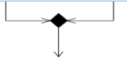 | Reunite different decision  paths created using a decision node.
Fork node |  | Slits behaviour into parallel or concurrent flows of activities (or actions).
Join node |  | Unites a set of parallel or concurrent flows of activities or actions.
Swimlane and partition |  | A way of grouping activities performed by the same actor in an activity diagram or to group actions in the same thread.

- Authenticate activity diagram
Figure 24 Authenticate activity diagram

- Consultation activity diagram
Figure 25:Consultation activity diagram

- Book appointment activity diagram
Figure 26 Book appointment activity diagram

CONCLUSION
In the analysis phase, we chose a software development process and modelling language, after which we explained the functional need of our system, we saw the use case diagram which shows the relationship between the actors and use case (the action the actor can perform on the system),we saw the communication diagram which represents the architecture of the system based on object oriented programming, we saw the sequence diagram which represents the flow of messages between elements in the system, and lastly the activity diagram which shows the workflow of our system. We will now move to the conception phase in which we will present the Technical branch of our system together with related diagrams.

PART V

CONCEPTION PHASE

TEST OF FUNCTIONALITIES

Preamble
The conception phase will permit us to present in an orderly manner the components necessary for the good functioning of our software and also the architecture used for the proposed solution. It bridges the gap between the analysis phase and the realization phase.

Content
INTRODUCTION
- TECHNICAL BRANCH
- GENERIC DESIGN
- CAPTURE OF TECHNICAL NEEDS
- RELATED UML DIAGRAMS
- CLASS DIAGRAM
- STATE MACHINE DIAGRAM
- PACKAGE DIAGRAM
CONCLUSION

INTRODUCTION
The conceptual phase will describe in detail the necessary specifications, features and operations that will satisfy the functioning requirements of the proposed system as modelled in the analysis phase. This phase is meant to identify and consider essential components (hardware /or software), structure (network capabilities), processes and procedures for the system to accomplish it objectives. We will look at some diagrams such as the class diagram, state machine diagram and package diagram.

A. GENERIC DESIGN

a. Hardware diagram of the system
The hardware diagram simply shows how the system components of our system are deployed; it shows the positioning of each device into it right proportion.

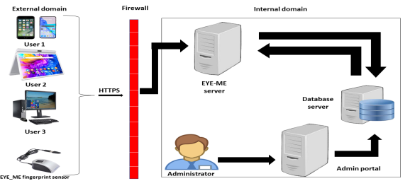

iKare server
Figure 27: Hardware diagram of the system

b High Level Architecture of the System
The high-level architecture diagram provides an overview of the entire system, identifying the main components that would be developed for the product and their interfaces

CAPTURE OF TECHNICAL NEEDS

Physical Architecture
The design of the DBMS depends on its architecture. An n-tier architecture partitions on the whole system into related but separated n modules, which can be independently modified, altered, changed or replace. A large amount of data on web servers, personal computers (pc) and others are link with networks with the help of basic client or server architecture.
Within the scope of our project, we made use of the n-tier architecture This architecture separate it tiers from each other based upon the user and the manipulated data in the database. Each layer has a well-defined communication interface, and the evolution of the layer is independent of the other. The n-tier of our system is made up of:
- The hardware tier, which represents our IOT device to collect vitals and it is connected directly to our mobile phone using a wired connection.
- The client tier, which is also known as our presentation interphase.
- Application Tier, which represents our webserver.
- The data tier, which represents our DBMS server.

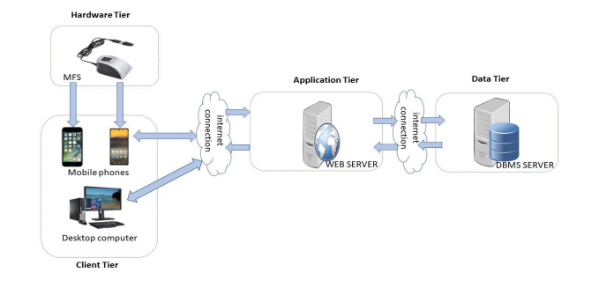
Figure 28: n-tier Architecture (Source: https://www.pinterest.es/pin/752241943987565648/)

Logical Architecture
Model View controller or MVC as it is popularly called, is a software design patten for developing application. A model view controller patten is made up of the following three parts.
- Model: The lowest level of the patten which is responsible for maintaining data.
- View: This is responsible for displaying all or a portion of data to the user.
- Controller: It handles software codes that controls the interactions between the model and the view.
MVC is popular as it isolates the application logic from the user interface and supports separation of concerns. Here the controller receives all requests for the application then works with the model to prepare data needed by the view. The view then uses the data prepared by the controller to produce a final response. The MVC can be represented as follows :

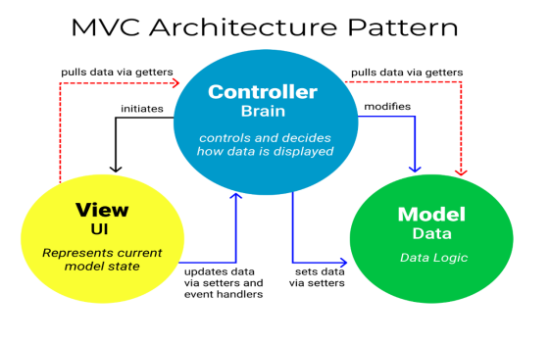
Figure 29: The MVC architecture (Source: https://www.freecodecamp.org/news/the-model-view-controller-pattern-mvc architecture-and-frameworks-explained/)

RELATED UML DIAGRAMS

CLASS DIAGRAM
- Definition
A class diagram is a static diagram. It represents the static view of an application. class diagram is not only used for visualizing, describing and documenting different aspect of the system but also for constructing executable code of the software application. Class diagram describes the attribute and operation of a class and constraints imposed on the system. Its purpose is to model the static view of an application.
- Formalism
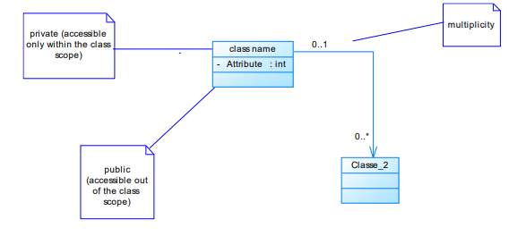
Figure 30: Formalism of Class Diagram

Table 17: Elements of class diagram
Element | Representation | Description
Class |  | A class is an element that defines the attributes and behaviors that an object can generate
Composition |  | If a parent of a composite is deleted, usually, all its parts are deleted with it.
Aggregation |  | If the parent of the aggregate is deleted, usually the children are not deleted.
Dependency |  | It existed between two classes, if one changes it may cause the change in the order, but the other way around
Generalization |  | it a relationship between a whole thing (called superclass) and a more specific thing (called subclass)
Association |  | It is a general type of relationship between elements, it may include cardinality, roles etc.

- iKare class diagram
Figure 31: System class diagram

- Business Rules
R1: A user manages one or more notifications, and a notification is managed by only one user.
R2: A user owns one or more roles, and a role is owned by one or more users.
R3: A lab technician manages one or more requests, and a request is managed by one or more lab technicians.
R4: An Institute admin administers one and only one hospital and a hospital is administered by one Institute Admin.
R5: A super admin manages one or more institute admins and Institute admin is managed by one super admin.
R6: A patient sends zero or many requests and a request is sent by one or more patients.
R7: A health professional issues prescription to one or more patients and a patient receives prescription from one or more health professionals.
R8: A patient is consulted by one or more health professionals and a health professional consults one or more patients.
R9: A patient books one or more appointments and an appointment is booked by one patient.
R10: A patient fills one or more follow-up forms, and a follow-up form is filled by one patient.
R11: A health professional manages one or more appointments, and an appointment is managed by one or more health professional.
R12: A health professional manages one or more follow-up forms, and a follow-up form is managed by one or more health professional.

STATE MACHINE DIAGRAM
- Definition
A state machine diagram describes the behaviour of a single object in response to a series of events in a system. Also known as the state machine diagram, it models the dynamic flow of control from the state of a particular object within a system.
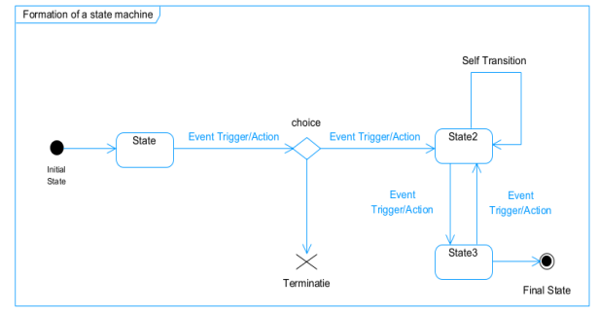
- Formalism
Figure 32: Formalism of state machine diagram

Table 18: Elements of state machine diagram
Element | Representation | Description
State |  | Models a situation during which a certain invariant condition holds.
First (Initial State) |  | It represents a default vertex, that is, a source for a single transaction to the default or composite state.
Final State |  | A state specifying that the enclosing region is complete.
Transition |  | A direction relation between a source and a target vertex.
Choice pseudo state |  | A diamond symbol that indicates a dynamic condition with branched potential results
Terminate |  | Implies that the execution of a state by means of it context is terminated.
Diagram overview | 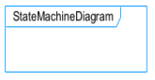 | A placeholder for the linked states in a state machine diagram.

- Account state machine diagram

Figure 33 Account state machine diagram

- Consultation state machine diagram

Figure 34 Consultation state machine diagram

- Appointment state machine diagram

Figure 35 Appointment state machine diagram

PACKAGE DIAGRAM
- Definition
This is a structural diagram used to show the organization and arrangement of various model elements in the form of packages. A package diagram is the grouping of related uml elements such as classes, diagrams or even other packages.
- Formalism
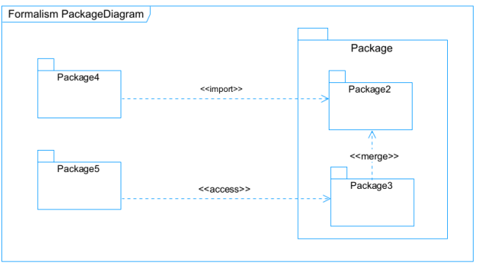
Figure 36: Formalism of package diagram

Table 19: Elements of package diagram
Element | Representation | Description
Package |  | A package is a namespace use to group related elements; it is a mechanism used to group elements into a better structure in a system.
Package import |  | A relationship Indicate that, functionality has been imported from one package to another.
Package access |  | A relationship Indicates that one package requires assistance from the function of another package.
Package merge |  | It is a relationship which shows that, the functionality of two packages are combines to a single function.

- iKare package diagram

Figure 37 iKare package diagram

CONCLUSION
In the conception phase, we set as objective to plane the different aspect of our system by showing how it will be structure and deployed within existing technical architectures. We began by considering the technical constraints for our system, after which we proceeded to identify the components of our system, how they are grouped together and how they should be deployed on appropriate deployment targets. We finished this phase by looking at interactions between the various aspects and actors of our system. The next phase of our report is the realization phase where we will look at aspects concerning the implementation of our system.

PART VI

REALIZATION PHASE

Preamble
In this phase we will to straight forward in the implementation of our solution, we will base ourselves on the analysis and conception phases and also present the component and deployment diagrams.

Content

INTRODUCTION
- DEPLOYMENT DIAGRAM
- COMPONENT DIAGRAM
CONCLUSION

INTRODUCTION
Here in the realization phase, we will see some diagrams related to the physical aspect pf the system like libraries, documents, as well as the physical topology of the components of the system when the software is been deployed.

DEPLOYMENT DIAGRAM
- Definition
Deployment diagram is a structural diagram used to visualize the topology of the physical components of a system, where the software is deployed. They consist of nodes and their relationship. It is related to the component diagram because the components are deployed using the deployment diagram. A deployment diagram consists of nodes. Nodes are nothing but physical hardware used to deploy the application.
- Formalism
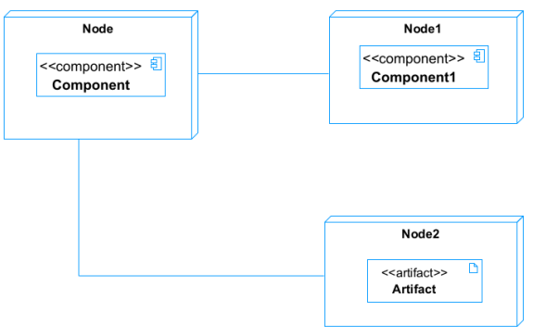
Figure 38: Formalism of deployment diagram

Table 20: Elements of deployment diagram
Element | Representation | Description
Node |  | It is a hardware used to deploy the application
Artifact | 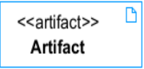 | An artifact is a major product, which is produced or used during the development of a software. E.g diagrams, data models, setup scripts
Component |  | It represents a modular part of a system that encapsulates its content and whose manifestation is replaceable within it environment.
Association |  | An association helps to connect two nodes together which permits them to communicate together

- System deployment diagram

Figure 39 iKare deployment diagram

2. COMPONENT DIAGRAM
- Definition
Component diagrams are used to model the physical aspect of a system. Now the question is what are this physical aspect? They are elements such as Executables, libraries, files, document etc. which resides in a node. The component diagram does not describe the functionality of the system, but it describes the components used to make those functionalities.
- Formalism
Figure 40: Formalism of component diagram (Source: https://www.pinterest.com/pin/551128073157994549/)
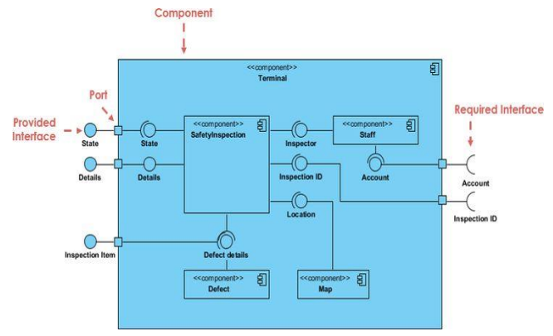
Table 21: Elements of component diagram
Name | Representation | Description
A Component |  | A component is an abstract logical unit block of a system.it is represented as a rectangle with smaller rectangle in the upper right corner which saves as it icon for recognition.
Dependency |  | Dependency is a directed relationship which is used to show that some components are dependent on others for their correct functioning.
Required Interface |  | It is a straight line from the component box with an attached half circle representing interfaces where a component requires information in order to perform its own functions.
Provided Interface |  | It is a straight line from the component box with an attached circle representing interfaces where a component produces information used by required interfaces
Port |  | A port (represented by a small square at the end of a required or provided interface) is used when the components delegate the interfaces to an internal class.

- System mobile component diagram
Figure 41 iKare mobile component diagram

- System web component diagram
Figure 42 iKare mobile component diagram

CONCLUSION
In our realization phase, we implemented our application. In other to accomplish this phase, we made used of our analysis and conception phase. We also drew the deployment and component diagrams which depict the structure of our system in terms of modules, files, assets, how the different elements interact with each other. We will move to the test of functionalities phase, where we will examine the different modules present in our app and how beneficial they are to its different users.

PART VII

TEST OF FUNCTIONALITIES

Preamble
In this phase, we will present the various functionalities of our application.

Content
INTRODUCTION
- APPLICATION FUNCTIONALITIES
- TESTS SHOWCASES
CONCLUSION

INTRODUCTION
The test of functionalities phase helps us to know more about the solution we are building be it web or mobile. It provides the different functionalities or modules found in our application and how they are beneficial to the users. Hence, we are going to explore the different functionalities present in iKare.

APPLICATION FUNCTIONALITIES
- Authentication
This functionality enables the users to have access to their workspace or dashboard. In case he/she does not have an account he/she will register.
- Consultation
It enables communication between the health professional and the patient through video calls or chat for diagnosis.
- Book and Manage Appointments
It helps patients book appointments for consultation and health professionals to either edit, cancel, approve the appointments received from patients.
- Pharmacy Search
At the end of a consultation, the health professional often issues prescriptions to patients, this module helps patients quickly identify the pharmacies nearby, having the drugs they are looking for and opened at the time.
- Follow-ups
When drugs have been taken, a regular follow-up is needed to make sure that the drugs taken by the patients have the desired effect on them. If the patient is not relieved from his illness, the doctor will be informed.
- E-Health Record
This module helps in keeping track of patients’ past records, to enable effective diagnosis to be carried out by future health professionals.
- Account and Notification Management
The users are capable of modifying account details by editing their passwords, profile, name, emails, profile pictures. Notifications are received by doctors and patients to remind them of approaching consultations, account creation (Health staff) and validation, also reminding patients to take drugs.
- Log out
It enables users to close a working session.

TESTS SHOWCASES
The following are the tests carried out using mocha, chai and chai-http on our APIs’ endpoints.
- Admin Modules tests
Here we have tested :
- /api/admin/getAdmins routes that enables the super administrator to get the list of all the admins created on the platform.
- /api/admin/createAdmin that enables the super admin to create an admin. If an admin already exists with that email address, it returns an error message. In this our case, there is a technical issue (due to network connectivity) reason why there is one 1 failing.

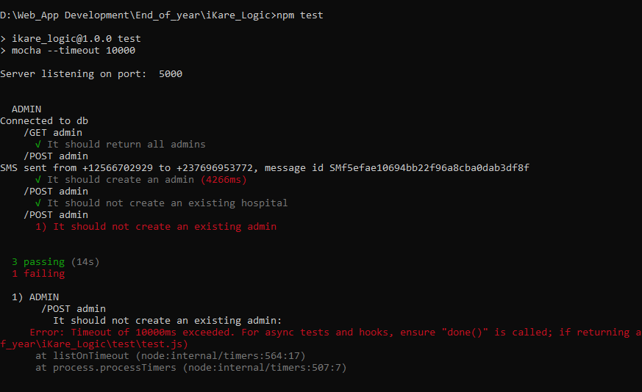
Figure 43: Admin Modules tests

- Health Professional Creation and Manage modules
Here we tested
- /api/admin/getProfessionals endpoint that enables an administrator to get all the health professionals registered in that institute.
- /api/admin/createProfessional endpoint that enables an administrator to create a professional if that matricle is not yet registered, in the reverse case an error message displays.

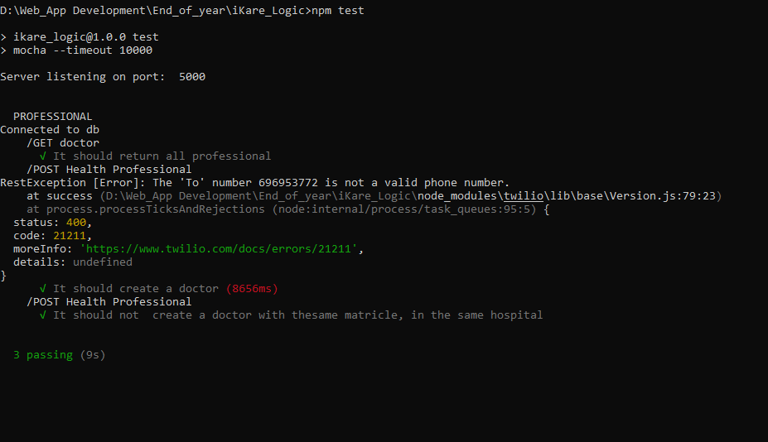
Figure 44: Professional Modules tests

CONCLUSION
In the test of functionalities phase we explained the different functionalities of our application and the benefits to the various users (patient, health professional, admin, lab technician, super admin). This phase is essential in the understanding of the application. We will move to the last phase which is the installation and user guide where we will elaborate on how to install and use iKare.

PART VIII

INSTALLATION GUIDE AND USER GUIDE

Preamble
The purpose of the user guide is to provide users of our platform with step-by-step instructions on how to install and use the system.

Content

INTRODUCTION
- INSTALLATION OF THE APPLICATION
- SHOW CASE
CONCLUSION

INTRODUCTION
This is the final phase of our report. In this phase we will walk through the requirements for our system, the necessary installation process, accessing our system and its features, all this in a step-by-step manner to facilitate the setting up of the platform for the first-time users. The steps of different processes will be accompanied by images. After we will showcase our application by viewing the different screens.

INSTALLATION OF THE APPLICATION

DATABASE SERVER INSTALLATION
To deploy a software, we need to install it database server, in our case in MongoDB will be installed in our system which is windows.

Figure 45 mongodb logo
STEP 1 : Downloading the mongoDB MSI installer package
We go to https://www.mongodb.com/try/download/community in other to download MongoDB an note that we are downloading the community version since it is free and open source.

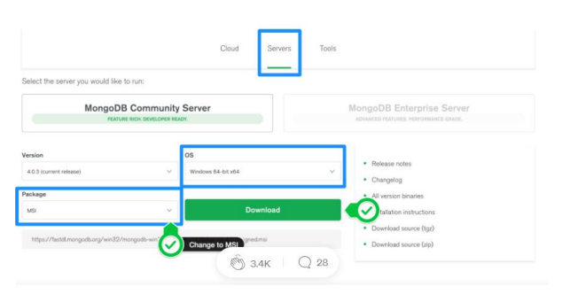
Figure 46 Downloading MongoDB community version

STEP 2: Install MongoDB with the installation Wizard
- Make sure you logged in as a user with admin privileges. Then navigate to your downloads folder and double click on the .msi package you just downloaded. This will launch the installation wizard.

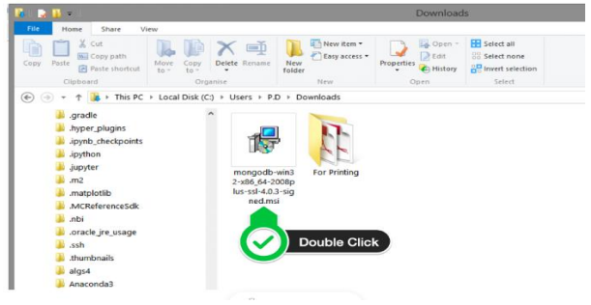
Figure 47 Launching the installation wizard
- Click on the next button
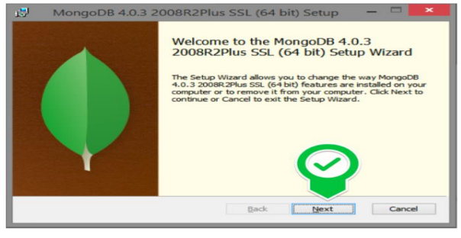
Figure 48 Clicking on next

- Accept the license agreement then click Next

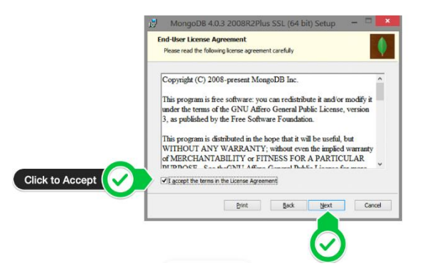
Figure 49: Agreement License
- Select the Complete setup
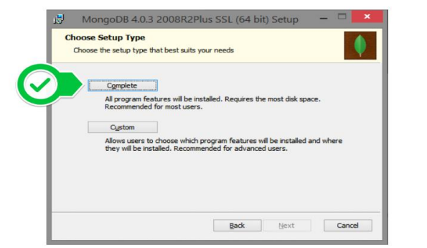
Figure 50 Select complete setup

- Select “Run service as Network Service user” and make a note of the data directory, we’ll need this later.
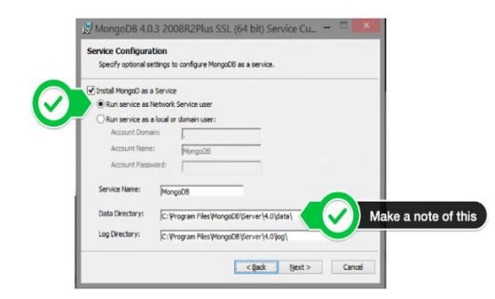
Figure 51: Run service network user
- Select mongo DB compass since you don’t have that already

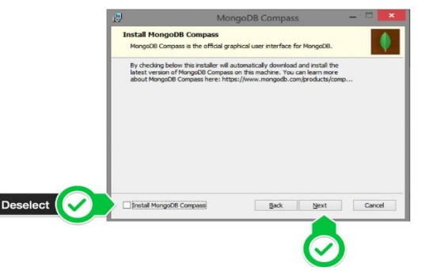
Figure 52: Selecting MongoDB compass and clicking next

- Click Install to begin installation
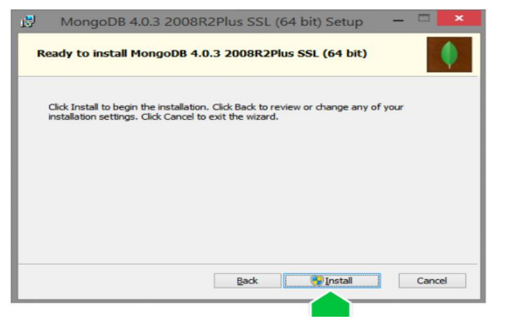
Figure 53: Click on install to start installation
- Click on finish to complete installation
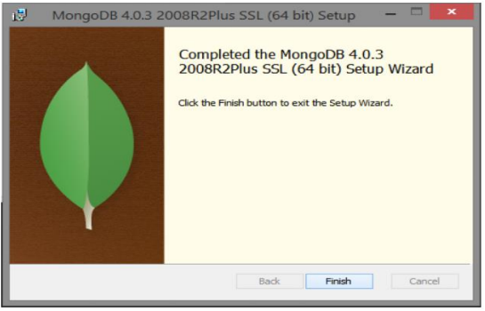
Figure 54: Click on finish to complete installation

MOBILE APPLICATION INSTALLATION
To be able to use iKare mobile application, we need to download the APK file or IPA file and install it. After installing it, run the application.

SHOWCASES
- Here we have the login screen
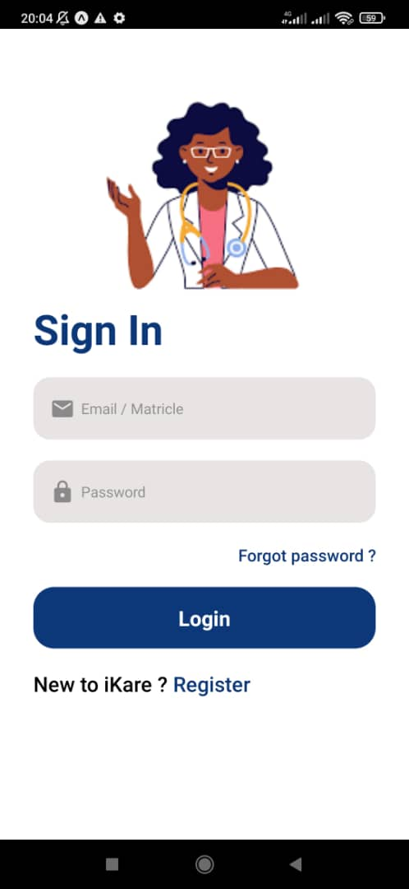
Figure 55: iKare login Screen

b) This is the register screen
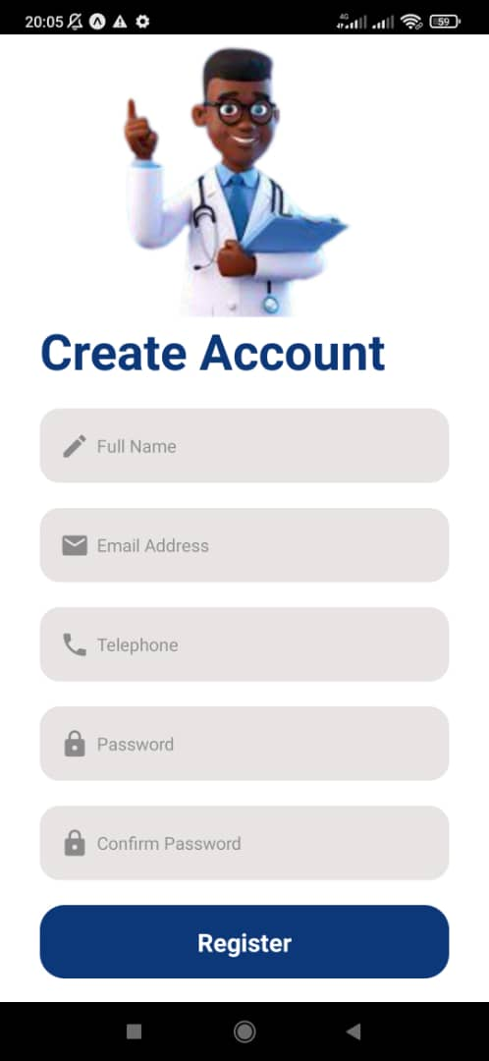
Figure 56: iKare register screen

- Here we have the patient’s welcome screen
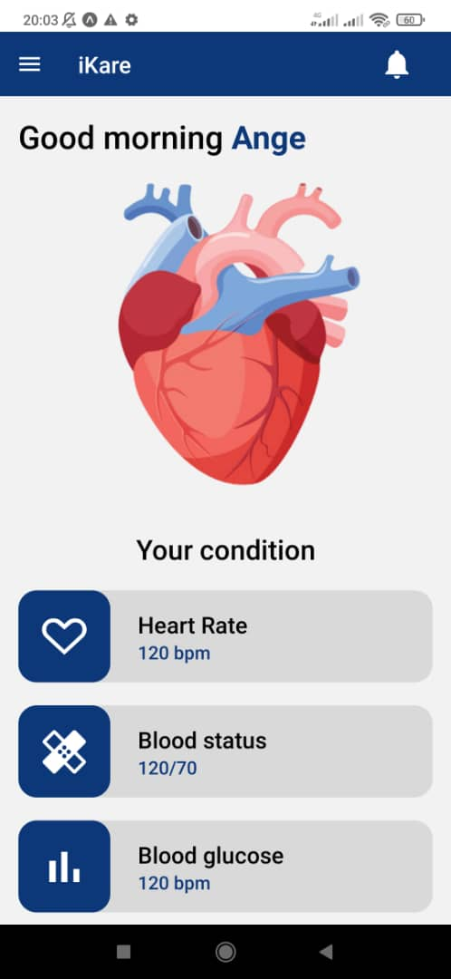
Figure 57: iKare patient's welcome screen

- Hospital Lists Screen
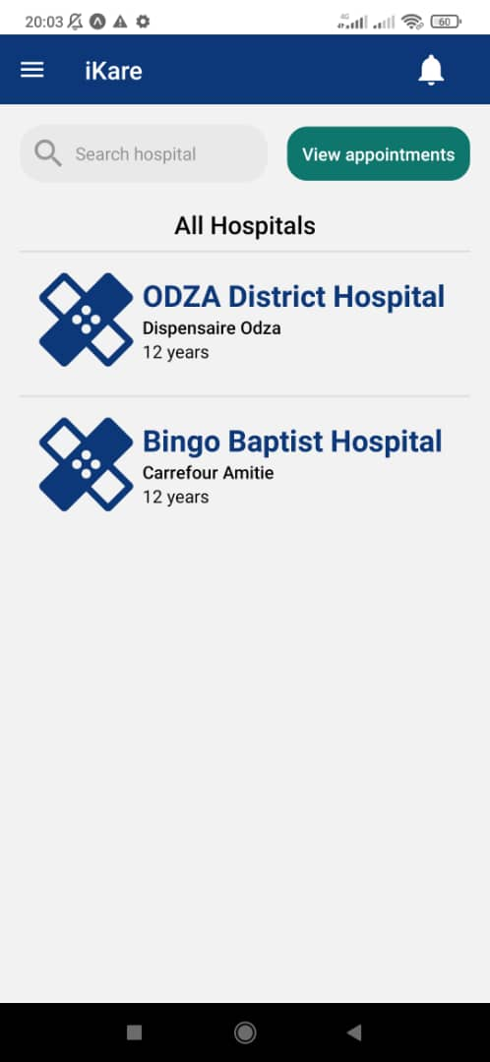
Figure 58: Hospital List Screen

- This interface is for booking appointments by patients
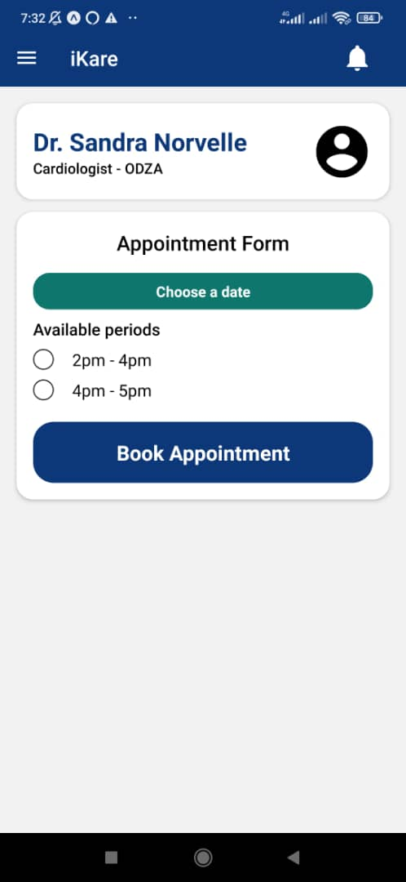
Figure 59: Book Appointment Screen

- Doctor’s home screen
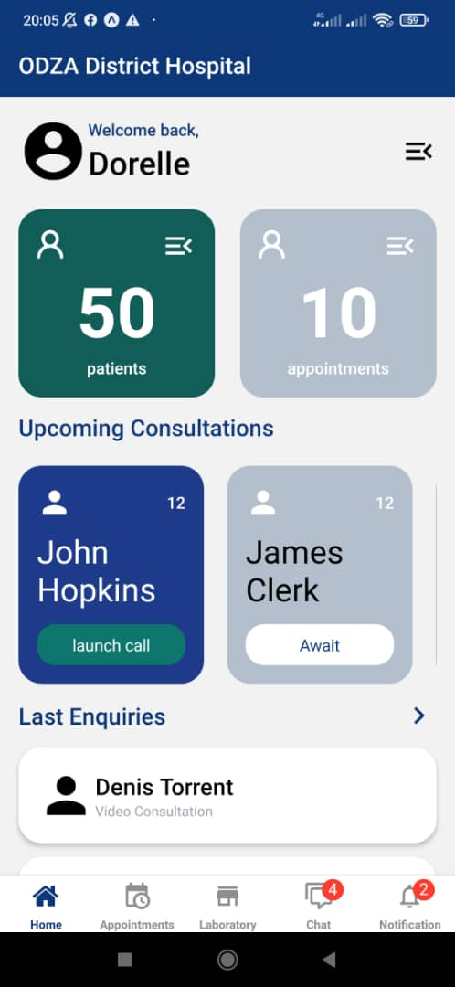
Figure 60: Doctor's home screen

- Doctor’s Appointments Screen
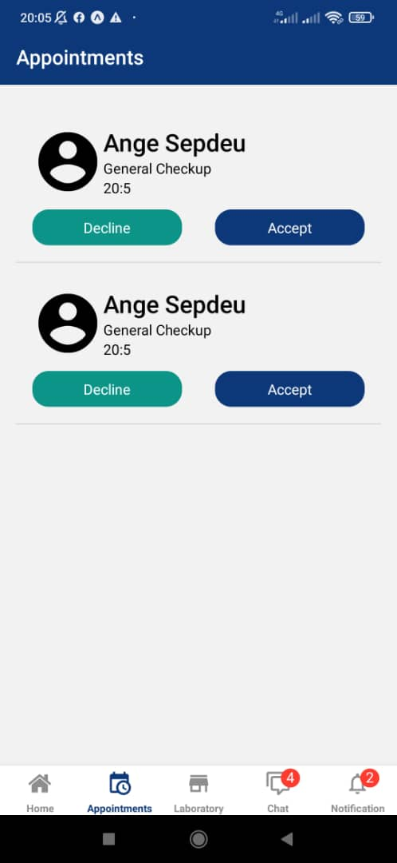
Figure 61: Doctor's appointment Screen

- Prescription Screen
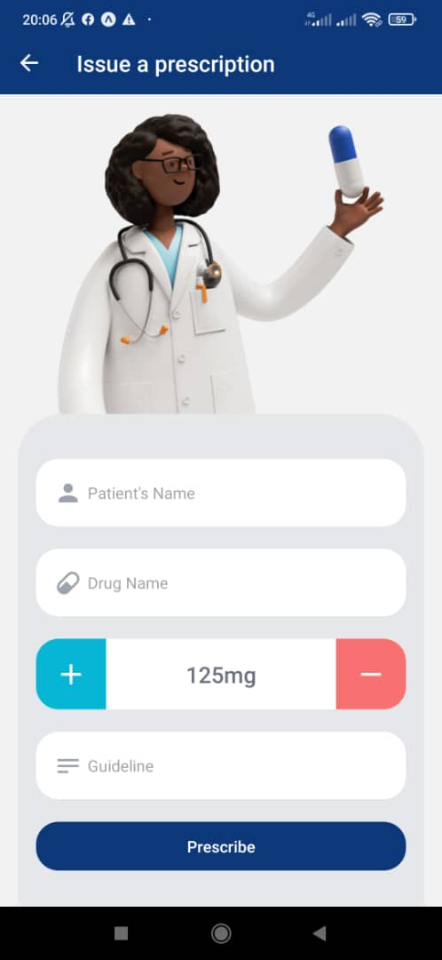
Figure 62: Prescription Screen

- Consultation Screens
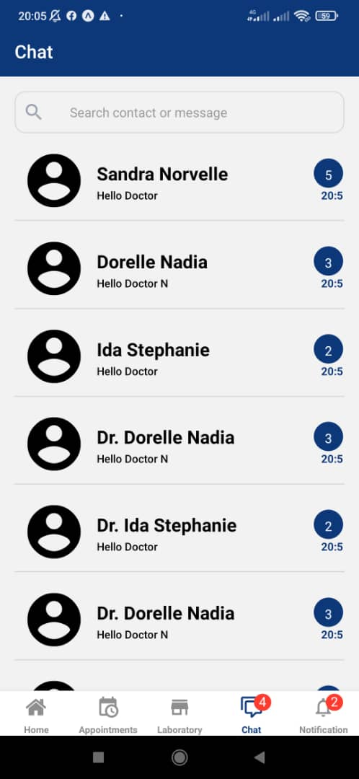
Figure 63: Chat Screen

Web Application
- Creation of Institute Admins page
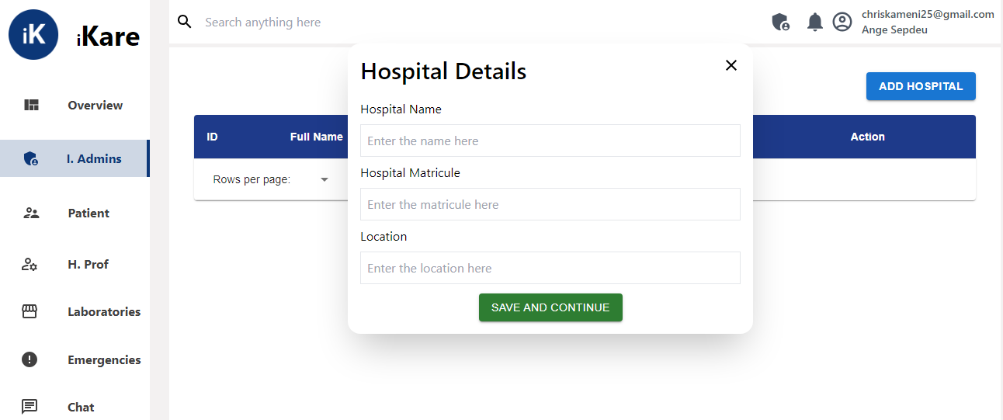

Figure 64: Admin Creation Page

- View Health Professional page
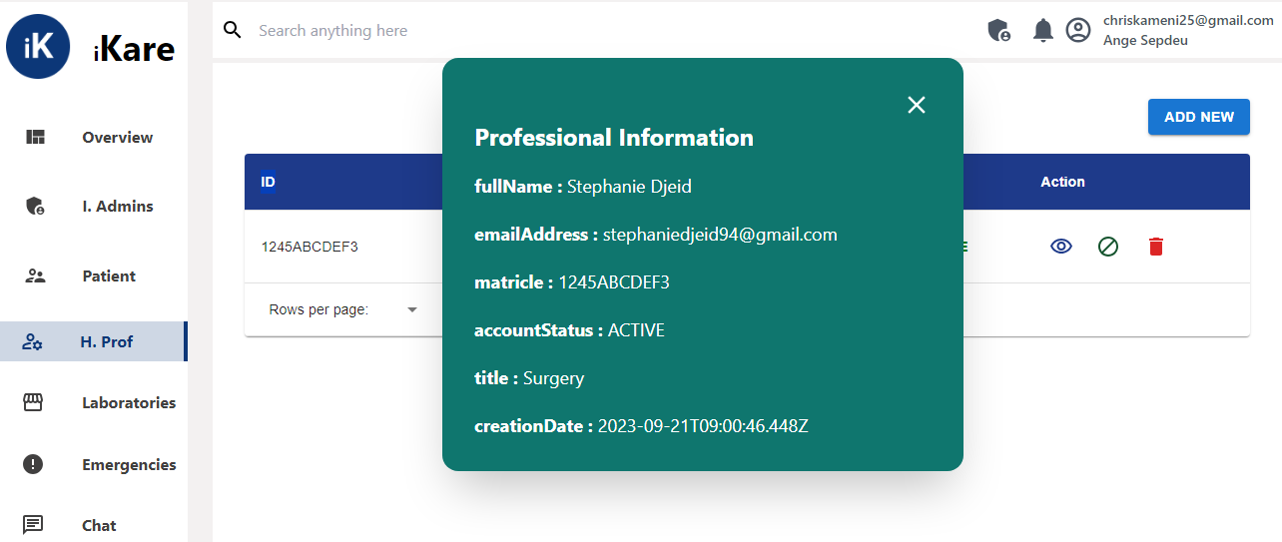
Figure 65: List of Health Professionals page

CONCLUSION
Having put in place the platform, it was not sufficient for we had to produce a manual that will help its various users. That is why we presented the different tools to be installed and how they are to be installed in order to run this application without any problem and how the users will use this platform once the environment is set up.

PERSPECTIVES
Considering the fact that this project can be improved to a higher extend, as perspectives we can bring some ameliorations such as:
- Implementing an IOT smart tool for collecting vitals.
- Using Virtual and Augmented Reality for Health Conferences.
- Developing an AI model for Cameroon.

Having come to an end of our project and the end of our internship at REALIZE, we have achieved a lot from our internship period, it was very challenging and demanding, we had to manage stress, failures and successes. Our stay in REALIZE was very profitable, we learned how to adapt to the professional milieu and to also work in team. For our project we worked on the theme “DEVELOPMENT OF A PATIENTS’ CONSULTATION AND FOLLOW-UP PLATFORM FOR CAMEROON GOVERNMENT HOSPITALS”, our greatest desire is to facilitate consultation, follow-up of patients and access to prescribe drugs by doctors. We began by identifying the current system in place for the consultation process, project constraints and requirements in the specification book, then we went forth to analyze our system (iKare) using UML-2TUP methodology. We made use of Sybase Power AMC, a modelling software used to draw our various diagrams. In order to realize our project, we used react-native for mobile front-end, React js for the front-end, NodeJS for the backend and MongoDB as our database. Our system, iKare will enable patients to book appointments for consultations, be consulted by a medical professional, receive notifications or reminders for medications or consultations. We won’t end here, updates and important improvements are going to be made in the nearest future in terms of functionality, security to make it more reliable.

GENERAL CONCLUSION

ANNEXES

BIBLIOGRAPHY

- Mercurial 2022
- International Journal of Database Management Systems ( IJDMS ) Vol.10, No.2, April 2018.
- Tracking 100 Core Health Indicators in Cameroon in 2019 & SDG Focus-En.

WEBOGRAPHY

- https://www.tutorialspoint.com/object_oriented_analysis_design/index.htm Object Oriented Analysis & Design Tutorial. July 15th, 2023, 09:00 PM.
- https://icograms.com/designer Designing a geolocalisation diagram. July 31st, 2023 09:00 PM.
- https://www.visual-paradigm.com/guide/uml-unified-modeling-language/what-is-class-diagram/ What is a Class Diagram? August 21st, 2023, 09:00 PM.
- https://formik.org/docs/guides/validation FORMIK documentation. August 24th 2022 10:30 AM.
- https://console.twilio.com/?frameUrl=/console SMS API information. August 31st, 2023, 5:30PM
- https://primereact.org DataTable. September 18th, 2023, 3:30 PM.
- https://www.mongodb.com/docs/mongoid/current/reference/associations/ Associations. September 21st, 2023, 4:30PM
- https://redux.js.org/tutorials/essentials/part-5-async-logic Async Logic and Data Fetching. September 22nd, 2023, 12:30PM.
- https://github.com/videosdk-live/webrtc/blob/main/react-native-webrtc-app/client React Native Video Calling App with react-native-webrtc. September 24th, 2023, 6:30 PM.
- https://www.scaler.com/topics/react-native-webrtc/ React Native Video Calling App with react-native-webrtc. September 24th, 2023, 7:30 PM.
- https://www.digitalocean.com/community/tutorials/test-a-node-restful-api-with-mocha-and-chai Test a Node RESTful API with Mocha and Chai. September 25th, 2023, 9:00 PM.

TABLE OF CONTENT

DEDICATION i
ACKNOWLEDGEMENT ii
Content iii
LIST OF FIGURES v
LIST OF TABLES viii
GLOSSARY ix
Abstract x
Résumé xi
General Introduction 1
PART I 3
INSERTION PHASE 3
Preamble 4
Content 4
INTRODUCTION 5
I. WELCOME AND INSERTION 6
II. GENERAL PRESENTATION OF REALIZE 7
A. Background: 7
B. Missions 7
C. Vision : 7
D. Activities 7
III. ORGANIZATION OF REALIZE 8
A. Administrative organization 8
B. FUNCTIONAL ORGANISATION OF REALIZE 10

IV. GEOGRAPHICAL LOCATION 11
V. BRIEF PRESENTATION OF THE PROJECT THEME 12
CONCLUSION 13
PART II 14
EXISTING SYSTEM 14
Preamble 15
Content 15
INTRODUCTION 16
I. PRESENTATION OF THE PROJECT THEME 17
II. DESCRIPTION OF THE EXISTING SYSTEM 18
III. LIMITATIONS OF THE EXISTING SYSTEM 21
IV. PROBLEMATIC 22
V. PROPOSED SOLUTION 22
CONCLUSION 23
PART III 24
SPECIFICATION BOOK 24
Preamble 25
Content 25
INTRODUCTION 26
I. CONTEXT AND JUSTIFICATION 27
A. Context 27
B. Justification 29
II. OBJECTIVES OF THE PROJECT 30
A. GENERAL OBJECTIVE 30
B. SPECIFIC OBJECTIVES 30
III. EXPRESSION OF NEEDS 31

1. Functional Needs 31
2. Non-Functional Needs 32
Performance, Scalability and Security 32
IV. PROJECT PLANNING 33
a. Chronogram of activities 33
b. Gantt Project planning 34
V. ESTIMATED COST OF THE PROJECT 35
a. Software Resources 35
b. Hardware Resources 36
c. Human resources 37
d. Global Estimation 37
VI. CONSTRAINTS 38
VII. LIST OF PARTICIPANTS AND DELIVERABLES 39
a. LIST OF PARTICIPANTS 39
b. DELIVERABLES 39
CONCLUSION 40
PART IV 41
ANALYSIS BOOK 41
Preamble 42
Content 42
INTRODUCTION 43
I. METHODOLOGY 44
1. COMPARATIVE STUDY OF UML AND MERISE 44
a. MERISE 44
b. UML 44
2. COMPARATIVE STUDY OF UNIFIED PROCESSES 47

a. A Unified Process 47
b. The Two Track Unified Process (2 TUP) 47
II. JUSTIFICATION OF THE ANALYSIS METHOD 50
III. MODELLING OF THE PROPOSED SOLUTION 51
A. Capture of Functional Needs 51
1. USE CASE DIAGRAM 51
2. COMMUNICATION DIAGRAM 61
3. SEQUENCE DIAGRAM 65
4. ACTIVITY DIAGRAM 70
CONCLUSION 76
PART V 77
CONCEPTION PHASE 77
TEST OF FUNCTIONALITIES 78
Preamble 78
Content 78
INTRODUCTION 79
A. GENERIC DESIGN 80
a. Hardware diagram of the system 80
b High Level Architecture of the System 80
B. CAPTURE OF TECHNICAL NEEDS 81
a. Physical Architecture 81
b. Logical Architecture 82
C. RELATED UML DIAGRAMS 83
1. CLASS DIAGRAM 83
2. STATE MACHINE DIAGRAM 88
3. PACKAGE DIAGRAM 93

CONCLUSION 97
PART VI 98
REALIZATION PHASE 98
Preamble 99
Content 99
INTRODUCTION 100
1. DEPLOYMENT DIAGRAM 101
2. COMPONENT DIAGRAM 104
CONCLUSION 108
PART VII 109
TEST OF FUNCTIONALITIES 109
Preamble 110
Content 110
INTRODUCTION 111
1. APPLICATION FUNCTIONALITIES 112
2. TESTS SHOWCASES 113
CONCLUSION 114
PART VIII 115
INSTALLATION GUIDE AND USER GUIDE 115
Preamble 116
Content 116
INTRODUCTION 117
I. INSTALLATION OF THE APPLICATION 118
A. DATABASE SERVER INSTALLATION 118
B. MOBILE APPLICATION INSTALLATION 123
II. SHOWCASES 123

C. Web Application 132
CONCLUSION 133
PERSPECTIVES 134
GENERAL CONCLUSION 135
ANNEXES ii
BIBLIOGRAPHY iii
WEBOGRAPHY iv
TABLE OF CONTENT v

